| **SDDS_SCN_V7.0.0_ECP_650** | |
| --- | --- |
| **Title: Use KVM to reduce the number of SDDS servers** | |
| Classification: TLP:**[1]** | |
| Originator: Leonardo  Via Tiburtina, 1020  00156 Rome  Italy | SIMOS-IP |
| Approval: EUROCONTROL  Rue de la Fusée, 96  Bruxelles  Belgium | SIMOS Team |

SCN Guidelines

Please refer to [SDDS-QUA-REQ-03 - SDDS SCN Guidelines](https://ost.eurocontrol.int/sites/SRSPR/SDDS/SERVICE%20MANAGEMENT/SIMOS%20IP%20CONTRACT/04%20-%20PROJECT%20RECORDS/06%20-%20RULES/03%20-%20GUIDELINES%20PROCESSES/SDDS-QUA-REQ-03%20-%20SDDS%20SCN%20Guidelines.docx)

# Impacted Components & Documents

## Impacted Components

CORE, MNG CONF, MNG SMC, ESPACE, SDDS OS

## Impacted Documents

<For all impacted documents, fill in the table below applying the following policy:

Doc-ID: The “SDDS Reference No” of the corresponding document released by EC for the version for which the SCN applies.

SharePoint File Link: Depending on the Change Reporting Method in use:

* Word track Changes Method: Link to the corresponding document that defines the System Change by usage of the "track change mode" of MS Word. The link name is the file name (without path) of the document.
* SCN Before & After Method: “N/A”

Edition No: The Edition Number of the document filled in behind SDDS Reference No

Applicable SCN: This must be filled-in if the ticket has dependencies with other tickets for the SCN integration i.e. whether other SCN(s) needs to be applied before this SCN:

* If so: the name(s) of those SCN(s)
* If not: “No”>

| **Doc-ID** | **SharePoint File Link** | **Edition No** | **Applicable SCN** |
| --- | --- | --- | --- |
|  |  |  |  |
|  |  |  |  |
|  |  |  |  |

# High Level Functionality

This ECP introduces the use of virtualisation in SDDS, to reduce the number of servers for the system. The system architecture will consist of two servers, each running VMs for CORE and MNG+WKS. No additional WKS will be supported (WKS3, WKS4, WKS5). The number of CORE building blocks will be limited to 1, increasing the maximum number of Logical channels to 800.

Figure – SDDS migration to virtualised solution

The network architecture will be changed to reduce the minimum number of network interfaces needed by the system. The relevant changes will be the optional configuration of interfaces for MNG and the optional bonding for the MNG. New features will be added for the configuration of the operating system of the physical server (host of the virtual machines), for example the possibility to configure an optional network interface for the management of the server (Management Network Interface).

The following terminology will be used in this document:

* **KVM Host (**or simply: **Host)**: physical server running Linux KVM. The extended form will be used to better identify the context, when needed.
* **Guest**: virtual machine running inside Linux KVM on the KVM Host, representing a virtualised SDDS server.

In the context of this ECP, which affects OS configuration, an additional security improvement will be introduced, denying remote ssh root access to the KVM Host and Guest (SDDS virtual servers).

## Analysis

### Hardware configuration

The current hardware architecture of the SDDS System is based on physical servers, each server running either CORE or MNG+WKS application. The minimum hardware architecture consists of four servers:



Figure – SDDS current hardware architecture

In Figure 2 the MNG and the WKS run onto a physical server. There are two servers in OPS/STAND-BY configuration representing the MNG Building Block and other two servers in OPS/STAND-BY configuration representing the CORE Building Block.

In the following paragraphs, the terms “MNG OS” and “CORE OS” will be used to indicate the SDDS OS installation of the Guests, executed respectively on MNG servers and on CORE servers. The ISO file is unique and the server where the OS is installed will be configured according to the Unit (CORE A, CORE B, or MNG A, MNG B) selected in the boot menu.

### Network configuration

The current network architecture requires ILAN, ELAN and IWAN both for CORE and MNG.

#### MNG side

All LANs (ILAN, IWAN, ELAN) for the MNG servers must have bonding configuration. If a network interface, required for the bonding, is not configured or not available, then the application does not start. A check about the number of interfaces is performed when the MNG application stars and if there are not 6 network interfaces (two for ILAN, two for IWAN and two for ELAN) the application shuts down.

The MNG uses the IWAN and the ELAN for the interconnection service (Service/Provider, disabled by default) and for the External SNMP monitoring. These services are provided by the OPS MNG through the Virtual IP addresses of both LANs.

#### CORE side

All LANs (ILAN, IWAN, ELAN) for the CORE are mandatory. The bonding is currently mandatory only for the ILAN. The IWAN and the ELAN can be configured also without bonding, but during the CORE OS installation the default configuration includes two network interfaces for the ELAN and the IWAN too.

On the CORE servers it is also possible to create User LANs with or without bonding and an additional LAN (XLAN) to directly connect the two CORE Units of the same Building Block for the exchanging of keep-alive messages.

### ESPACE tool

To customise the configuration of the CORE and MNG OS two options are possible:

* make use of a post-installation that will be executed at the first root login, or
* make use of a configuration tar file created by ESPACE tool.

ESPACE currently supports the offline configuration of the SDDS OS related to the MNGs, COREs and WKSs. The tool allows the configuration of:

* Bonding for ILAN, IWAN and ELAN. The bonding is mandatory for all the LANs of the MNG, and it’s required to define two network interfaces for each LAN. About the CORE instead, the bonding is mandatory only for the ILAN, the ELAN and the IWAN can be configured also with only one network interface (and then without bonding).
* IP addresses of the ILAN, IWAN and ELAN,
* Hosts file,
* Alive messages, Reverse Path filter and User LANs only for the CORE BBs,
* Linux password for root and sdds user,
* Workstation auto-start, (WKS application automatically started on sdds User logon),
* NTP,
* IPSec.

### CORE building blocks

The current SDDS System allows up to 20 CORE Building Blocks, each block supporting up to 400 Logical channels, 400 Inputs, 400 Outputs and 400 Data streams.

### Remote access to the system

The SDDS servers are currently configured to allow remote ssh root access.

## Solution

### Hardware configuration

The proposed solution is to co-locate CORE server and MNG+WKS server on a single physical server, using Linux KVM virtualisation technology. The supported hardware for the KVM Host servers consists of HP DL 360 Gen10 and HP DL 365 Gen11.



Figure – SDDS new hardware architecture

Regarding Linux KVM virtualisation technology, a KVM Host OS customisation will be created, in order to generate the environment to implement the solution shown in Figure 3.

About Guest OS (SDDS OS related to the CORE and MNG Virtual machines) a customisation of the OS is already available, and it will be updated to meet the new requirements as defined in the paragraph 2.2.2.2 (i.e: MNG OS with only the ILAN network as default configuration).

The description of the KVM Host OS customisation is available in 2.2.6.

### Network configuration

#### General aspects

The proposed solution for network configuration makes use of network bridge to share the interfaces of the KVM Host with the running Guests.

It’s important to remark that bonding must be defined at Guest level (no changes to current SDDS MNG and CORE network architecture), and that the interfaces of the KVM Host should not be assigned an IP address.

For system LANs, each interface used by SDDS requires the definition of a bridge mapped on a physical interface of the KVM Host. The bridge will be shared between CORE and MNG Guests, meaning that one physical interface of the KVM Host will be used by both MNG and CORE. When bonding is required on a system LAN, the proper number of physical interfaces (two) of the KVM Host must be assigned to a bridge.

Figure – SDDS network architecture

The Linux KVM software doesn’t automatically align the status of the bridged network interfaces of the Guests to the status of the corresponding network interfaces of the Host. On the Host, a service based on a shell script has been developed to ensure such alignment. The script will continuously check the status of the physical interface of the Host (physical server) and will set the status of the corresponding bridged interfaces accordingly. The setting of the status will be performed at Host level, using Linux KVM facilities on the Host, and avoiding any operation to be executed inside the Guest.

Due to the new network architecture and the migration to a virtual environment, MNG and CORE must be updated as specified in the next paragraphs.

#### Guest MNG side

It was requested that the default configuration for the Guest MNG OS (OS for the MNG server) will only include the ILAN with bonding. The IWAN and the ELAN networks are optional as well as their bonding, so they won’t be created by the default SDDS OS installation (MNG virtualised servers).

In details, the MNG will support the following configuration of system LANs:

* ILAN: mandatory and in bonding.
* ELAN: optional. If configured, bonding is optional.

The default MNG OS installation does not create the ELAN. The ELAN can be created during the post-installation or by ESPACE configuration file if needed.

* IWAN: optional. If configured, bonding is optional.

The default MNG OS installation does not create the IWAN. The IWAN can be created during the post-installation or by ESPACE configuration file if needed.

To apply these new requirements, the MNG OS and the MNG application will be updated as described below.

##### Update of the OS of the MNG VM

The updates to the MNG OS are related to the network configuration and the default settings. The OS of the MNG server will create, by default, only the ILAN with bonding (two network interfaces).

If the User needs to change the default settings, to use the ELAN and the IWAN, during the post-installation (or by ESPACE tar) he can apply these changes as shown in the following figure.

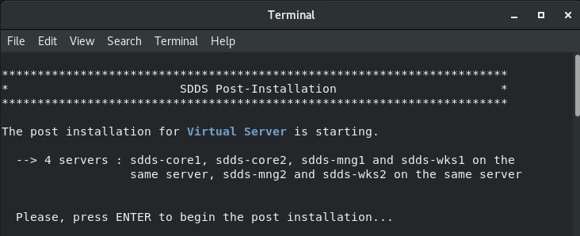

Figure – Post-installation: Start

As in the previous SDDS OS version, in the step 1 of the post-installation it is possible to configure the hosts file:

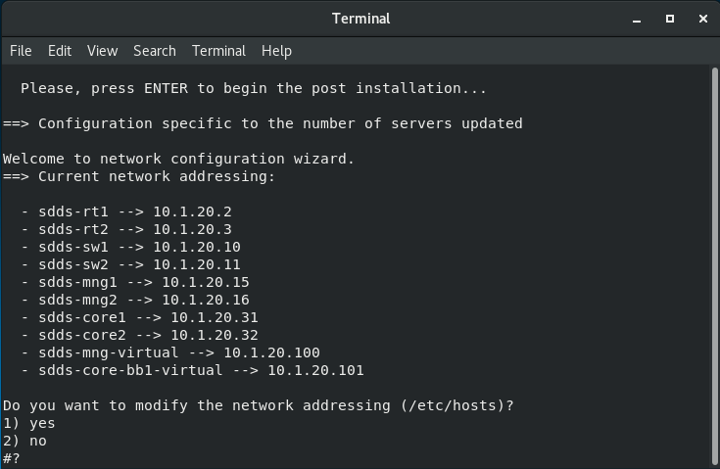

Figure – Post-installation: host file configuration

In the step 2 it is possible to configure the networks and the IP addresses. The shell in Figure 7 shows the current default settings for the ILAN only. The User can confirm or change the settings.

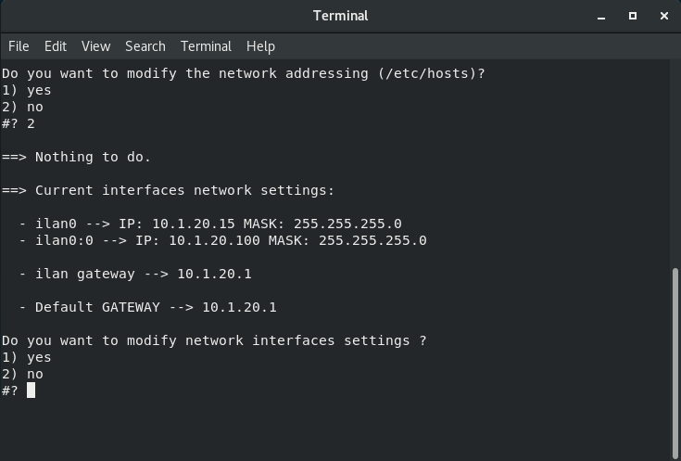

Figure – Post-installation: Current settings with the default ILAN only

Selecting the option 1 it is also possible to add, as displayed in Figure 8, the IWAN and the ELAN networks and insert the related IP addresses.

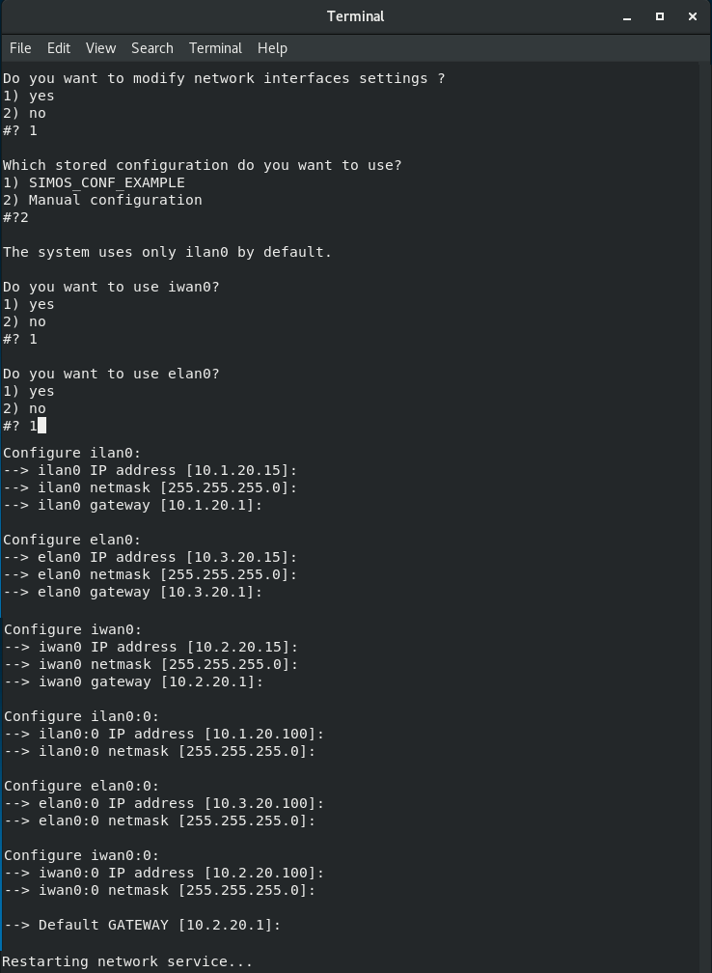

Figure 8 – Post-installation: Example where IWAN and ELAN are added to the default MNG OS configuration.

After having specified the IP addresses, the network service will be restarted and a summary of the configuration about the networks will be displayed (Figure 9).

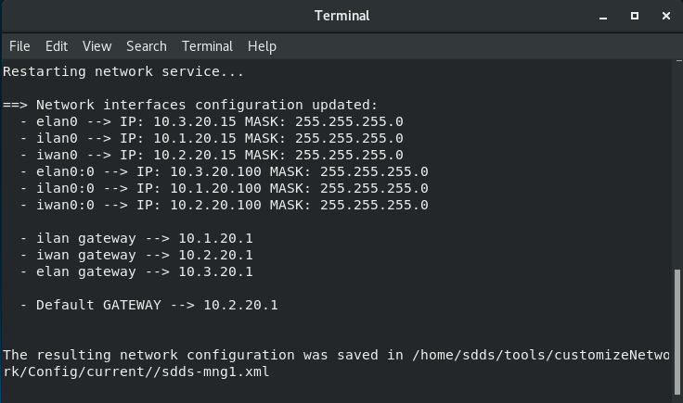

Figure 9 – Post-installation: Current settings of the LANs and the IPs after the update

Next step is to configure the bonding interfaces to use. By default, only the ILAN and its two network interfaces are defined. If in the previous step the User added the ELAN and the IWAN, it’s also required to specify the network interfaces for these two LANs and whether they must use the bonding or not (Figure 10).

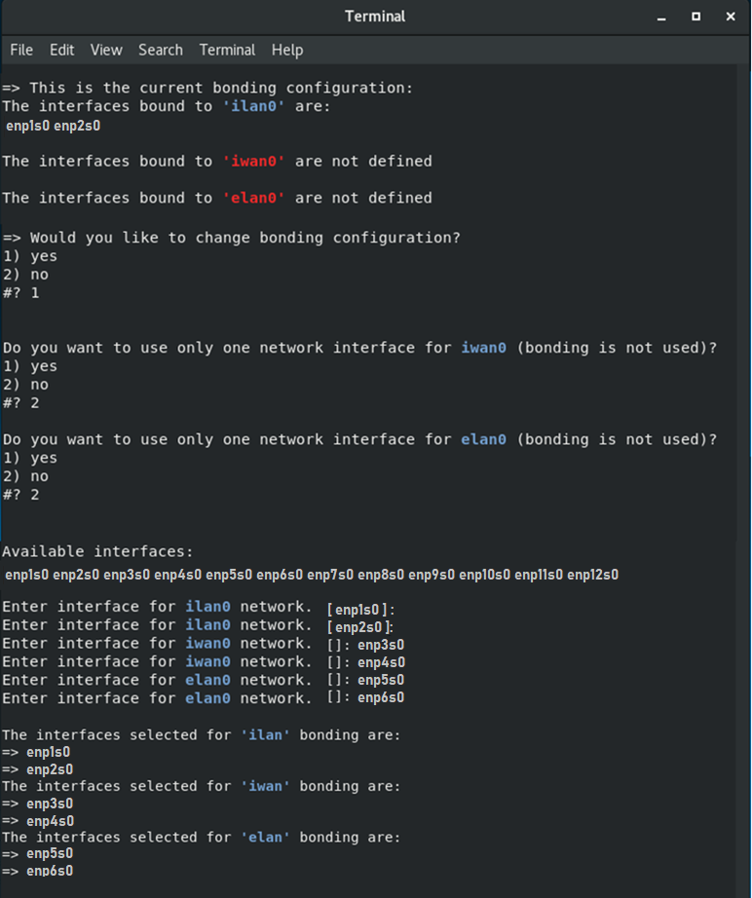

Figure 10 – Post-installation: Insert network interfaces to use for the bonding (Added IWAN and ELAN with bonding)

After all the network interfaces have been inserted by the User, a confirmation is requested in order to apply the new mapping between the LANs and their network interfaces (Figure 11). At the end of the network configuration, a menu is displayed in order to make other changes or exit from the networks configuration and continue the post-installation steps.

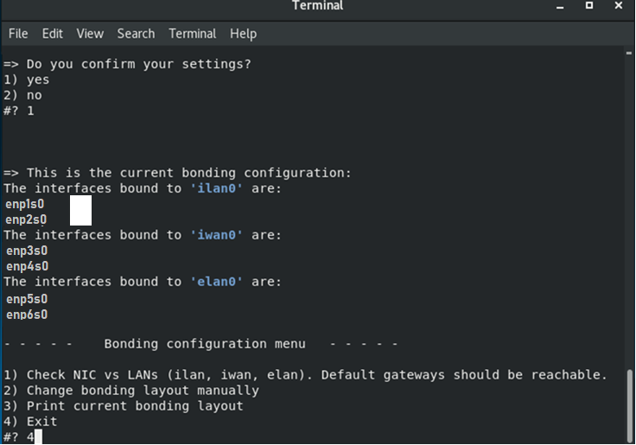

Figure 11 – Post-installation: Mapping between System LANs and network interfaces (bonding configuration)

The settings about the network configuration can also be changed at a later time, using the script customizeNetwork.sh, available in the folder:

/home/sdds/tools/customizeNetwork/script/  
The behaviour of the script will be the same as described in the previous post-installation figures.

Next steps of the post-installation are:

* enable or disable the Workstation auto-start,
* change the root and sdds user passwords (Figure 12),
* enable or disable VNC connection to the MNG/WKS (Figure 13)
* set the password rules for SDDS Users (Figure 13 - ECP 768).

The final step is the server reboot.

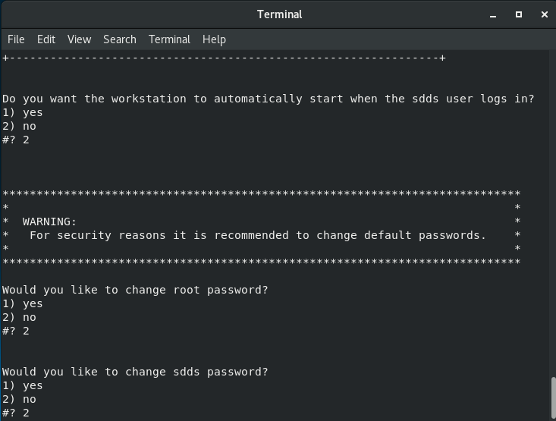

Figure 12 – Post-installation: WKS auto-start configuration, root and sdds user password update

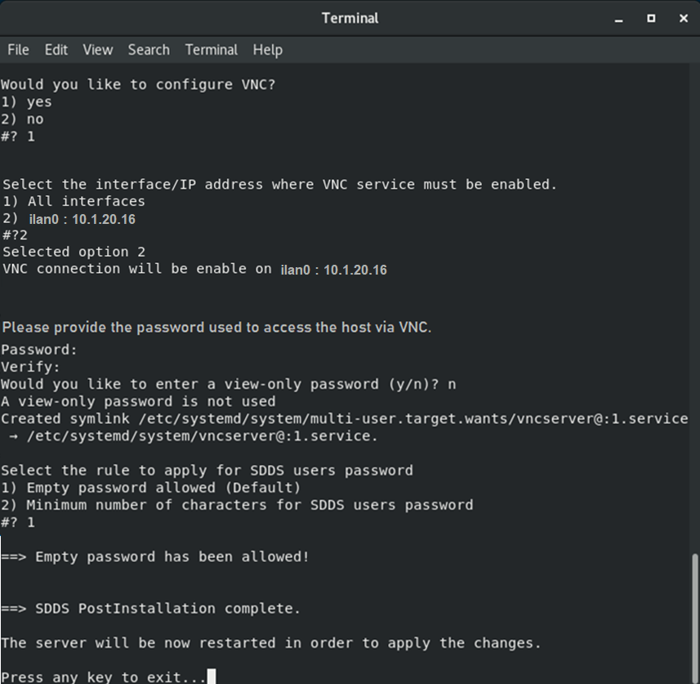

Figure 13 – Post-installation: VNC and SDDS password rules configuration.

##### MNG Application updates

Due to the new default configuration of the LANs (the ILAN only), the MNG source code will be updated in order to use the available System LANs only and the OPS services will be started on a LAN if it exists.

The MNG service are related to:

* SNMP Monitoring & Control (ILAN, IWAN, ELAN)
* Services/Providers (IWAN, ELAN))
* Remote SDDS Connection (IWAN)

For example, if the IWAN and the ELAN have not been defined then, when the MNG becomes OPS, the External SNMP Agent will not be started on the Virtual IP address of the IWAN and ELAN because the IPs are not available (LANs not configured). In this case it will be available on the ILAN Virtual IP only. Furthermore, it won’t be possible to use the service/provider functionality (disabled by default by a previous ETR) and the remote SDDS connection that should be performed using the IWAN.

#### Guest CORE side

The CORE already supports the following configuration of system LANs:

* XLAN: optional, no bonding.
* ILAN: mandatory with mandatory bonding too.
* ELAN: mandatory, optional bonding.

The default CORE OS installation creates the ELAN with bonding.   
The bonding can be removed during the post installation or by ESPACE configuration file.

* IWAN: mandatory, optional bonding.

The default CORE OS installation creates the IWAN with bonding.   
The bonding can be removed during the post installation or by ESPACE configuration file.

##### CORE OS updates

No needs for update related to the CORE OS customisation for this ECP.

##### CORE Application updates

Starting from ECP346 (Adding Extra LANs) the network interface management implemented by CORE considers ILAN, ELAN, IWAN as User LANs. The only difference is that their names hardcoded and not read from a configuration file. This solution allows to cope with the new requirements with no changes to the CORE code.

### ESPACE

ESPACE tool will be updated to allow the configuration of the Host OS and to manage the new settings for the SDDS OS configuration related to the new network architecture and to the fact that SDDS has moved to a virtual environment.

##### Host OS Configuration

A new menu item will be added to the current ESPACE tool to configure the Host OS installation.

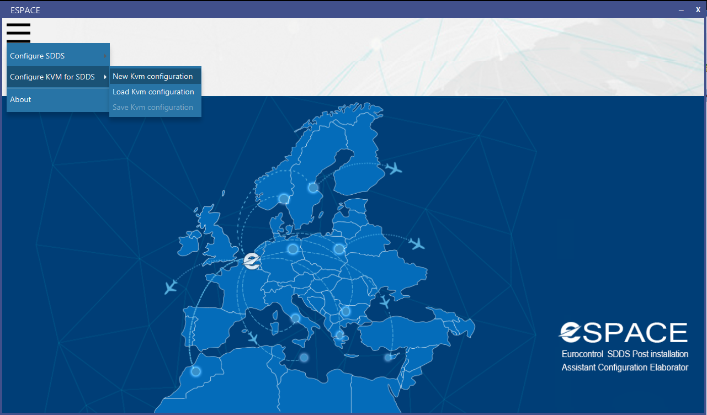

Figure 14 – New Menu item about Host OS configuration.

After the selection of the menu item to configure Host OS, the hardware platform must be selected from a list, in order to load the proper server image during the network configuration.

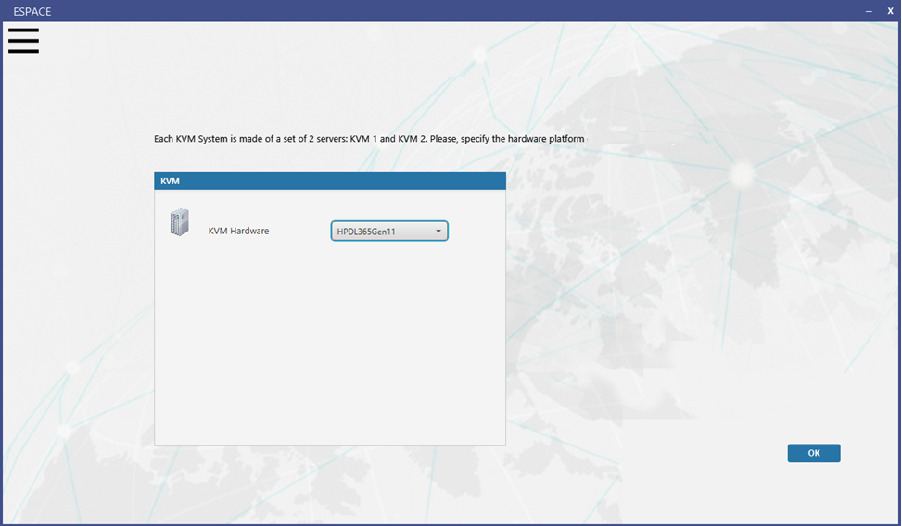

Figure 15 – Hardware selection (DL 365 Gen 11, DL 360 Gen10 and Other).

After having selected the hardware, a summary will be displayed where it is possible to start the wizard configuration, update the Host hardware or proceed with the OS configuration navigating the tab panels.

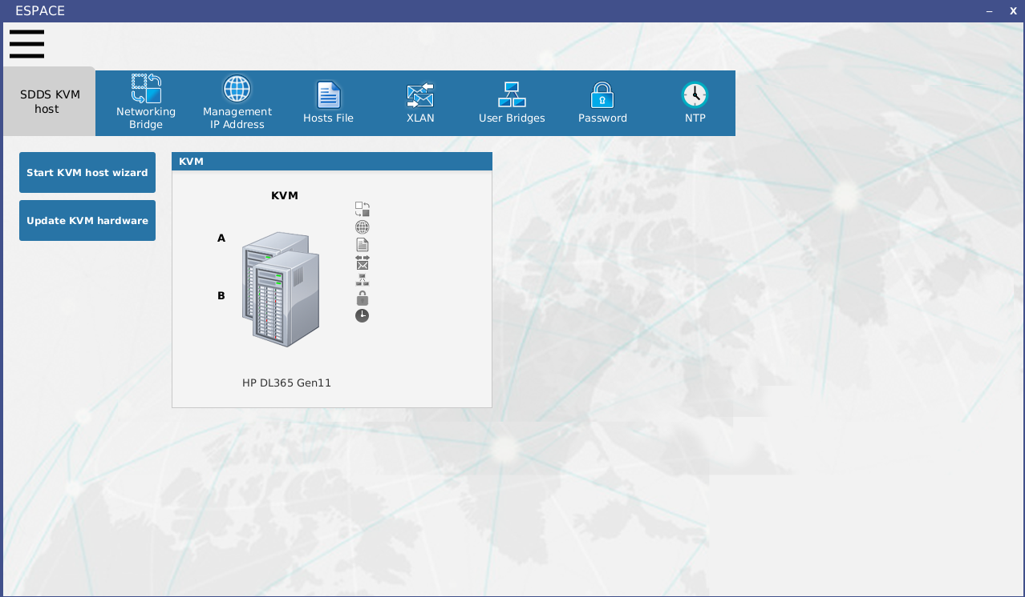

Figure 16 – Host to configure.

The first panel (Figure 17) is related to the definition of the System LANs and the Management network interface used to remotely connect to the Host. The use of ILAN, IWAN and ELAN in the Guests requires the definition of network bridges on the Host. If bonding for a LAN is required by a Guest (SDDS virtual server), two bridges must be defined on the Host, assigning a physical network interface to each bridge. The names of the System LANs bridges will be (Figure 40):

* ilanbridge1, ilanbridge2 (for the bonding. Both mandatories),
* iwanbridge1 (mandatory), iwanbridge2 (optional, to be defined if bonding on IWAN must be used by the SDDS Guest VM),
* elanbridge1 (mandatory), elanbridge2 (optional, to be defined if bonding on ELAN must be used by the SDDS Guest VM).

The name of the bridge does not contain the name of the physical interface on which it has been created. This is done to avoid that, changing a physical interface of a bridge, it needs to also change the settings of the SDDS Guest VM using the updated bridge.

The ILAN of the SDDS Guest VMs must have the bonding and then it is mandatory to define two bridges (2 physical interfaces). IWAN and ELAN can be configured on the SDDS Guest VMs also without bonding and then on the Host it’s not required to configure two bridges for each of them.

The management network interface is not mandatory but is recommended to connect to the Hosts by the Local Network. It can be used for example for VNC, ssh connection, NTP synchronisation, etc..

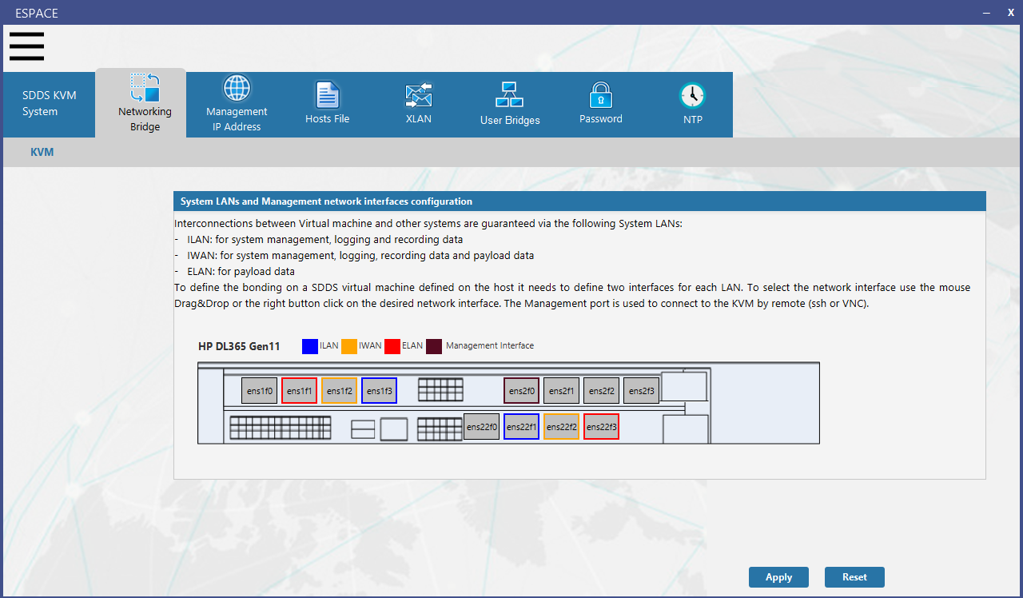

Figure 17 – System LANs bridge definition and mapping between bridges and physical interfaces.

In case “Other” is selected in the Hardware option (Figure 15), the names of the network interfaces must be manually inserted by the user in the proper text fields.

If the Management network interface is specified, then it is possible to define the settings in the next panel “Management IP Address” (Figure 45)

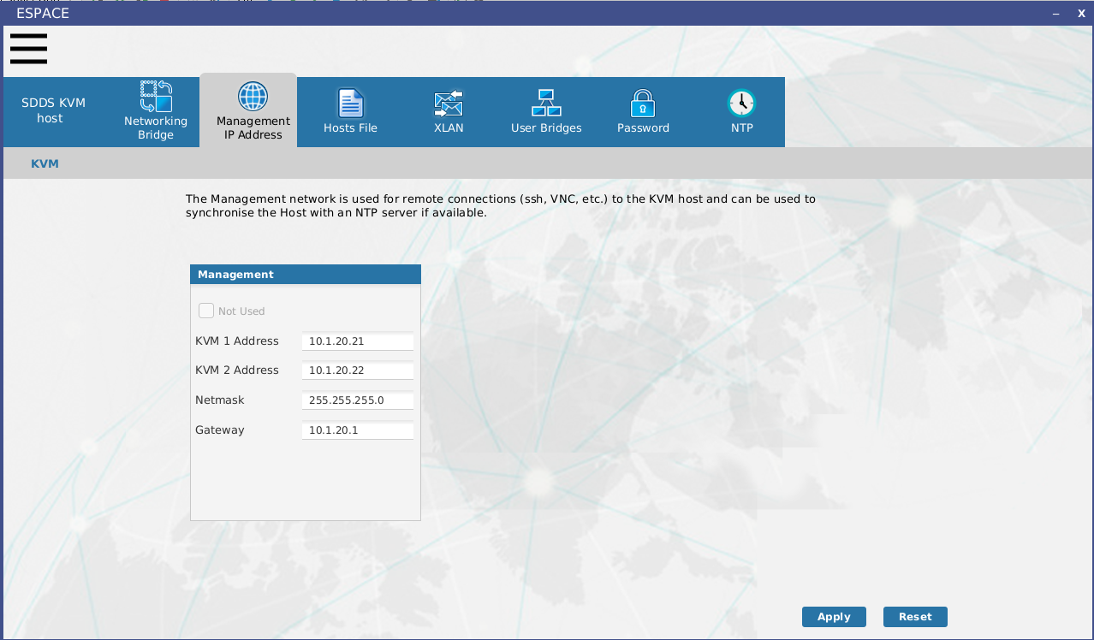

Figure 18 – Management network configuration.

In the panel related to the hosts file configuration (Figure 19), if the Management network has been requested, the host names of the KVM Host 1 (sdds-hypervisor1) and KVM Host 2 (sdds-hypervisor2) will be added by default, with their IP addresses for the Management network. It is also possible to add other host names.

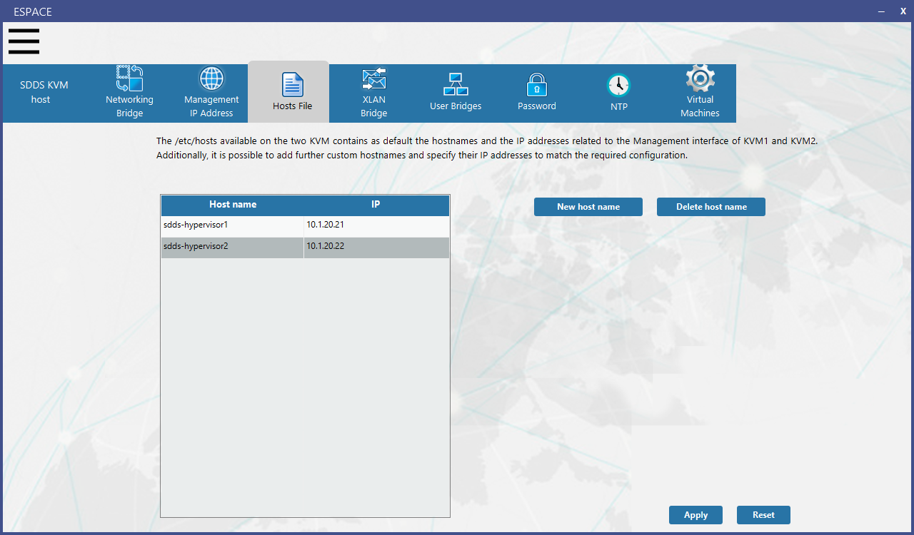

Figure 19 – hosts file configuration.

In case the CORE virtual machines of KVM1 (CORE A) and KVM2 (CORE B) need to exchange also Alive message on the XLAN, then it’s required to define a bridge for the XLAN and specify the network interface to use. A network cable must connect the two physical network ports of the KVM Host 1 (sdds-hypervisor1) and KVM Host 2 (sdds-hypervisor2).

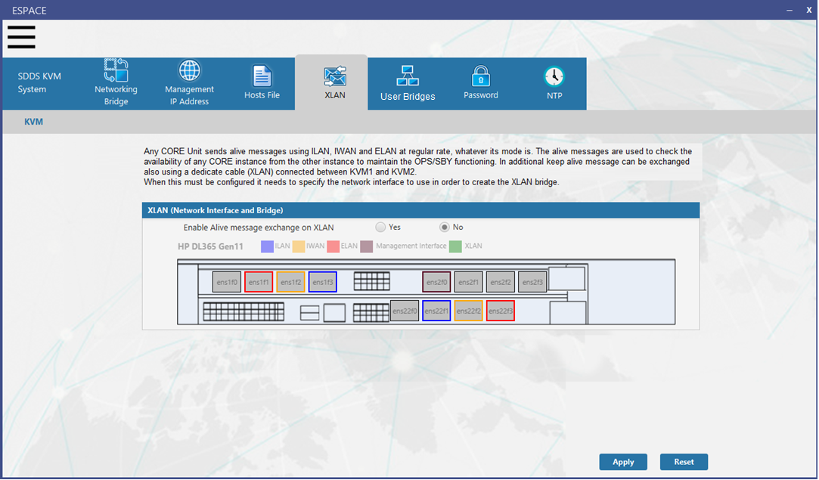

Figure 20 – XLAN bridge.

In the Figure 21 and Figure 22 it is possible to create User bridges.

Defining User LANs on the CORE (a Guest on the Host) requires the definition of at least a bridge on the Host. If the User LAN has the bonding, then two network interfaces must be selected to create two bridges.

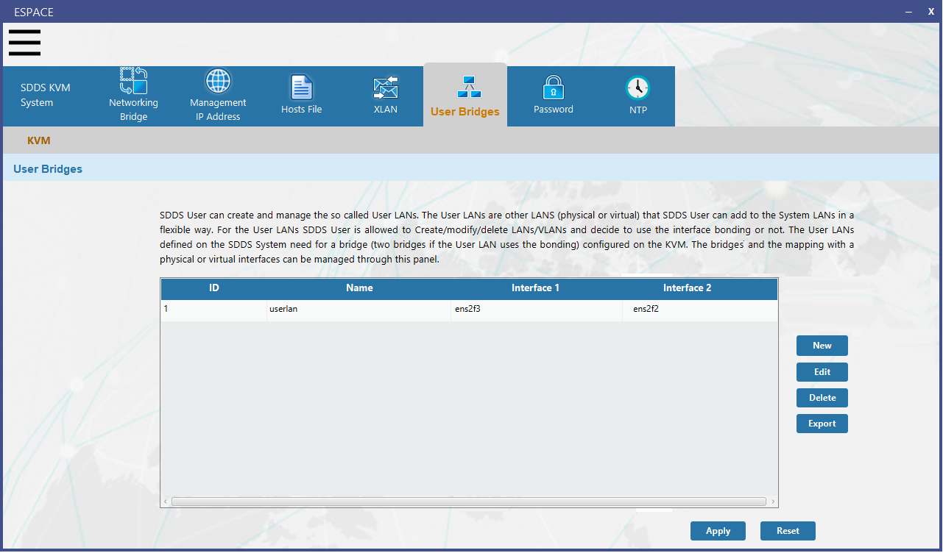

Figure 21 – User bridges list.

In the example in Figure 22, it has been created a User bridge named userlan, using the network interfaces ens2f0 and ens2f3. Installing the Host OS and using the ESPACE tar created with this configuration, two bridges will be created: userlanbridge1 using ens2f3 physical interface and userlanbridge2 using the ens2f2 physical interface.

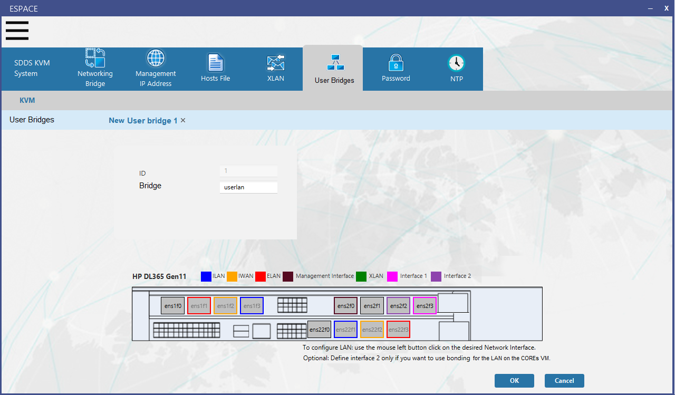

Figure 22 – User bridge create/edit.

In the panel in Figure 23 it is possible to customise the password of root, the password of sddskvm user and to enable the VNC connection to the Host.

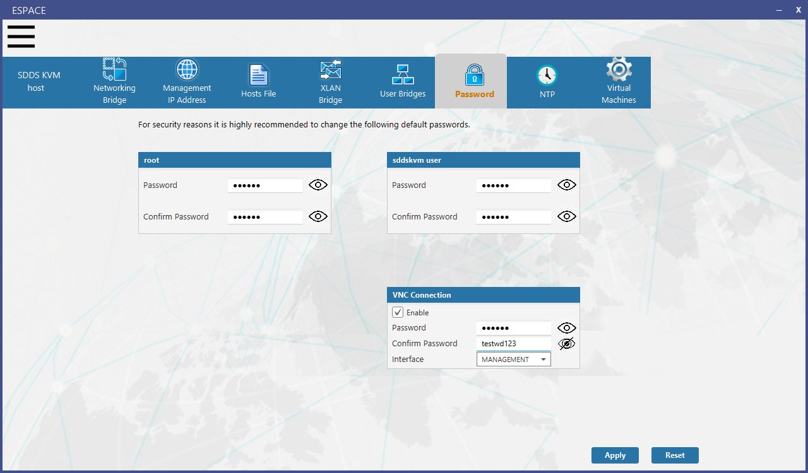

Figure 23 – KVM root, sddskvm passwords and VNC configuration (password and interface).

In the panel in Figure 24 it is possible to configure NTP. It can be applied a default configuration, where the two KVM Hosts are peers like MNG NTP configuration, and it can be specified one or two IP addresses of a remote NTP server. If an external NTP server will not be used by the Hosts, then the first option ensures that, at least, the two KVM Hosts are synchronised each other, using the same NTP default configuration used by the MNGs:

/etc/chrony.conf of KVM Host 1

# NTP configuration

peer sdds-hypervisor2

# to synch with an external server

#server X1.Y1.Z1.T1 iburst prefer

#server X2.Y2.Z2.T2 iburst

/etc/chrony.conf of KVM Host 2

# NTP configuration

peer sdds-hypervisor1

# to synch with an external server

#server X1.Y1.Z1.T1 iburst prefer

#server X2.Y2.Z2.T2 iburst

From an operational point of view, the synchronisation of the two KVM Hosts is not relevant.

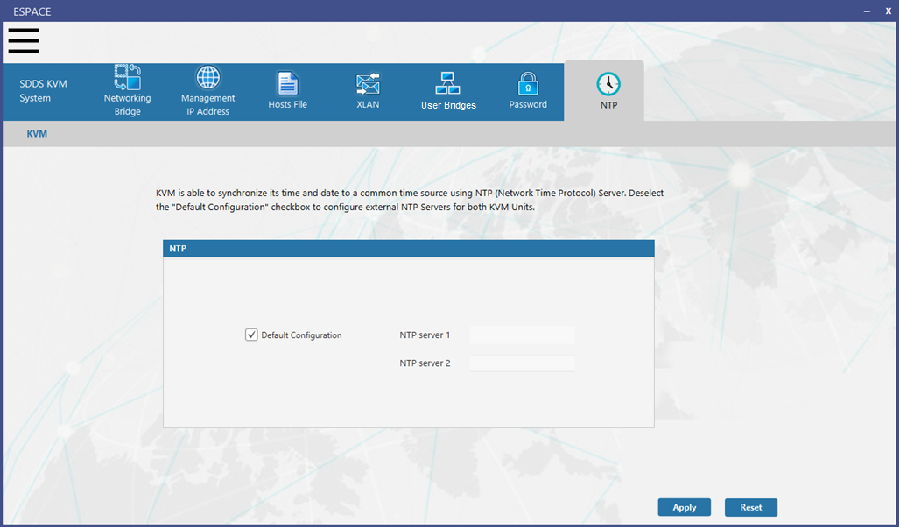

Figure 24 – NTP configuration.

The last configuration is related to the Virtual Machines that will be created on the Host. It is possible to specify the name of the virtual machines, the title, the description, the number of the CPUs, the amount of the RAM and the disk size of the CORE and MNG Guests.

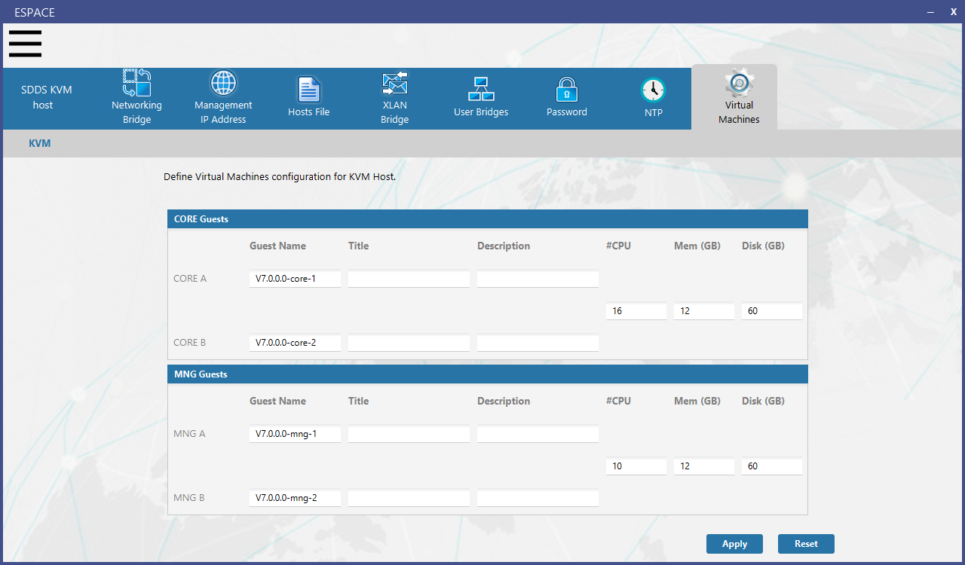

At the end, the configuration must be saved, and the ESPACE tar file must be inserted in a folder (/kickstart_SDDS/ansp-extra/configuration) of the usbstick to be used during the Host OS installation.

##### SDDS (Guests) OS configuration

The ESPACE tool already provides the possibility to configure the OS of the Guests (CORE and MNG virtual servers). It must be updated in order to apply the new requirements for the networks configuration (MNG with ILAN only as default configuration) and some additional features.

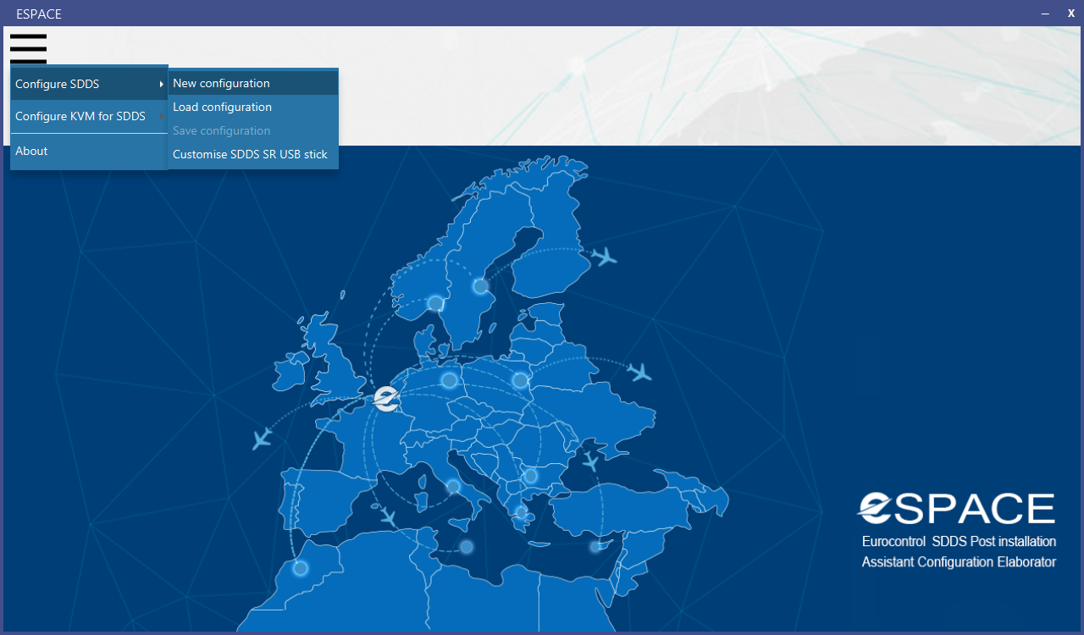

Figure 25 – ESPACE SDDS OS Configuration.

Starting the tool and selecting the option to configure OS of the Guests, it’s required to select the hardware platform of the Host, because the naming of the network interfaces inside the Guest depends on the hardware of the Host. It will not be possible to update the number of the CORE BBs, and the additional Workstations. The SDDS System will be based on 4 Guests as described in this document.

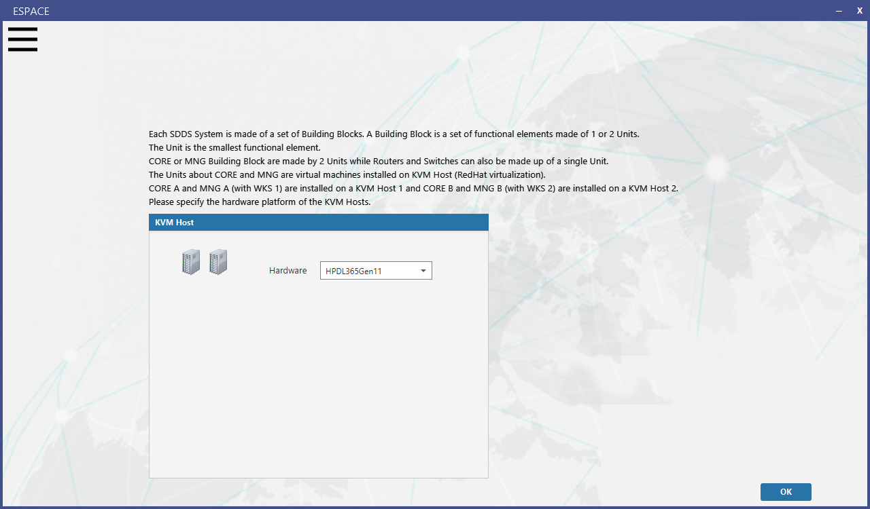

Figure 26 – KVM hardware selection in order to load the names of the network interfaces of the virtual machines CORE and MNG on the host (Gen10, Gen11 and other).

The configuration of the bonding by the panel showing the rear of the physical server with the network interfaces has been removed, since these are virtual servers. The network interfaces to use for the ILAN, IWAN and ELAN can be specified in the IP Addresses configuration panel (Figure 27).

It will be possible to specify the name of the network interfaces to use for the bonding through a combo-box containing the proper name of the “virtual interfaces” based on the type of hardware selected for the Host.

In case the selected hardware type is “other” the combo-box can be edited in order to manually insert the name of the interface.

For HP DL 365 Gen11 and HP DL 360 Gen10 the provided interfaces names are enp1s0, enp2s0, … , enp10s0,.., enp12s0.

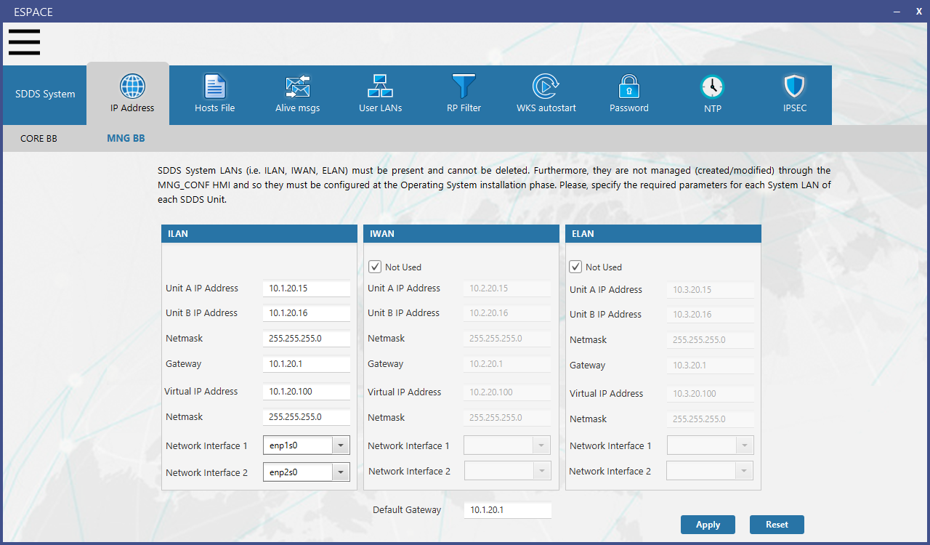

Figure 27 – MNG OS IP and bonding default configuration.

In the Figure 27, as default for the MNG, the IWAN and the ELAN are marked as “not used” but removing the checks it is possible to configure their IP and the network interfaces to use for the bonding (two network interfaces) or without bonding (only one interface).

In Figure 28, the default hostnames inserted in the SDDS OS /etc/hosts file are displayed. The hostnames related to switch and router can be removed if they are not available.

The Tab Hosts file has been added below for a more complete description of Espace, although it’s not involved in the updates related to the ECP 650.

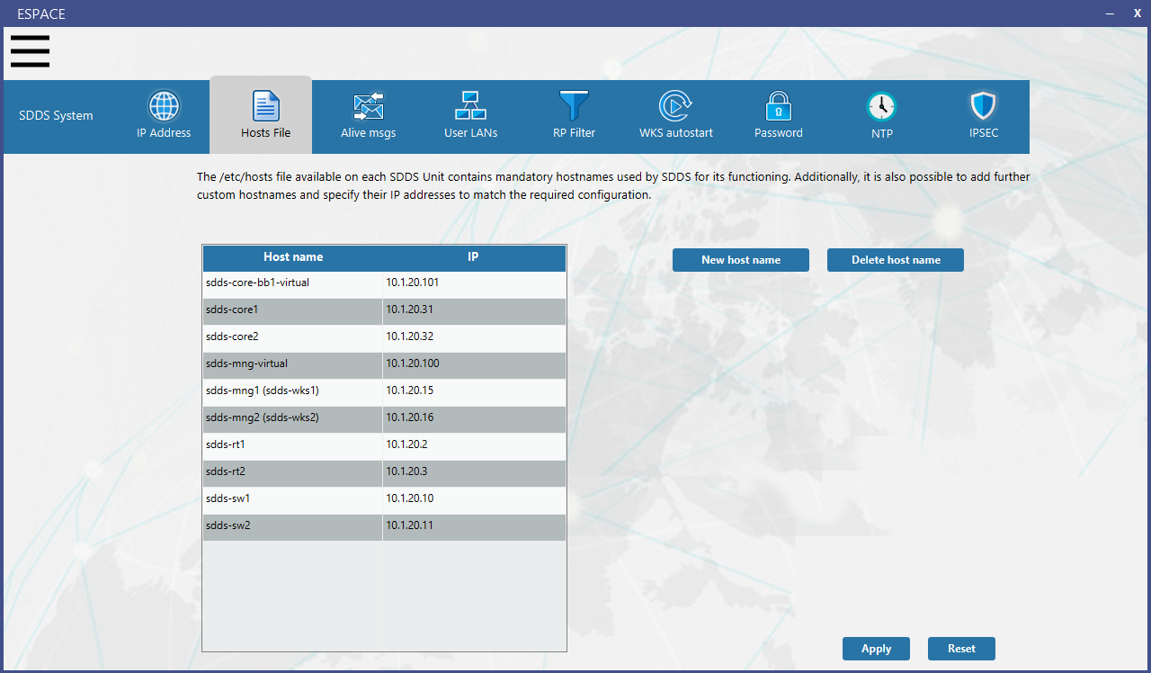

Figure 28 – SDDS servers hosts file

In the panel used to configure the passwords (Figure 29), it has been added the configuration of VNC to remotely connect to the WKSs on MNG1 and MNG2. In the same panel it is also possible to define the SDDS User password rules added in ECP 768.

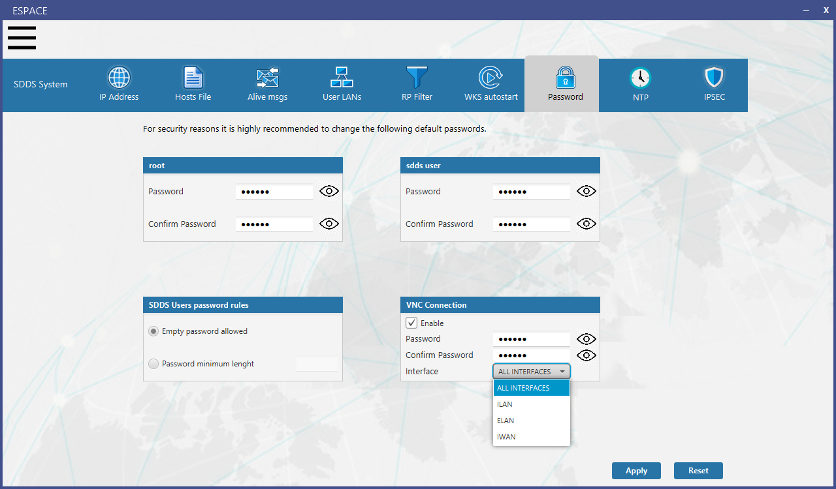

Figure 29 – Root and sdds user passwor update, SDDS Users password rules configuration and VNC configuration(password and interface).

### CORE Building Blocks

The maximum number of configurable CORE BBs will be fixed to one. An SDDS System will have only one CORE BB, one MNG BB, up to two Routers BB and up to one Switch BB.

#### Guest MNG side

About the SDDS HMI, it will be updated to avoid adding more than one CORE Building block to a Configuration Set and to be able to define up to 800 Logical channels. The maximum number of distribution objects (Inputs, Outputs, Data streams, Logical channels) that can be created will be increased from 400 to 800. Also, the maximum number of Data Flows will be increased from 200 to 400.

The SDDS-MIB.txt file will be updated to increase the range of the available Inputs, Outputs and Logical channel from the current [1,400] to the range [1,800].

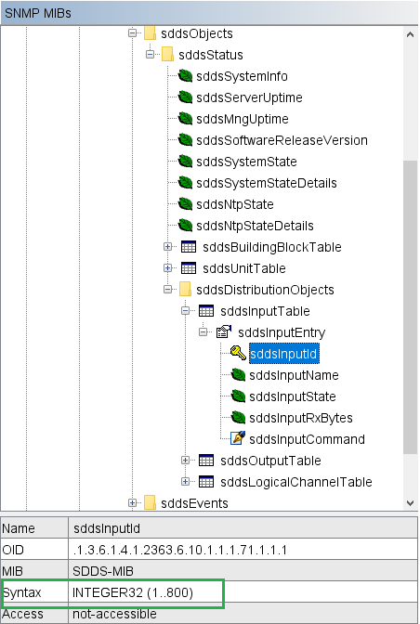

Figure 30 – SDDS MIB IDs range update.

Moving from 400 to 800 LCs, the issue related to the ETR 453 will be fixed too. The deployment of the CS, when there are many distribution objects (Inputs, Outputs, LCs, DS), locks and it is not completed. The problem is related to an untar command executed during the CS deployment performed by a script. The untar command provides a log line for every file contained in the tar (Figure 31).

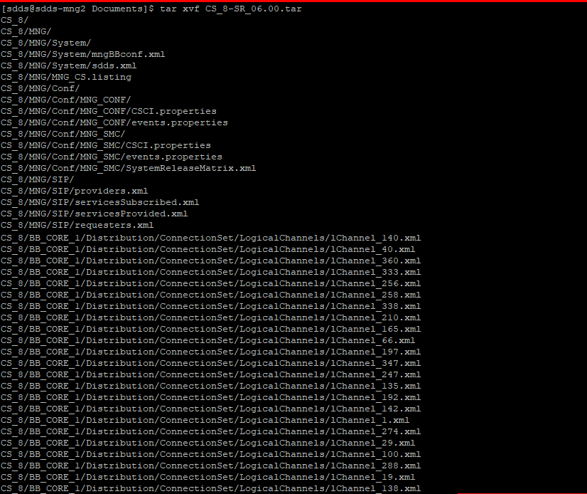

Figure 31 – Output of the untar command.

This log is written in a buffer that is not read and cleaned up by the thread executing the script. The solution consists to add a thread to clear the buffer reading every log message.

#### Guest CORE side

In SDDS CORE code, the number of Logical channels, Inputs, Outputs, Data streams and Data flows are defined by means of literals declared by pre-compiler directives in the file CORE-COMMON/types/include/SDDSTypes.h. Since all references to the maximum number of such objects are made by using these literals, their update is the only modification needed to increase their number.

Currently, the code that defines these literals is the following:

#define MAX_INPUT_NUMBER 400

#define MAX_OUTPUT_NUMBER 400

#define MAX_DATASTREAM_NUMBER 400

#define MAX_LOGICALCHANNEL_NUMBER 400

#define MAX_DATAFLOW_NUMBER 200

#define MAX_STATICFILTER_NUMBER 200

#define MAX_DYNAMICFILTER_NUMBER 200

As shown, each constant is defined separately, even if they are connected to the number of logical channels. To improve the code readability and maintenance, we propose to modify the section in the following way:

#define MAX_LOGICALCHANNEL_NUMBER 800

#define MAX_INPUT_NUMBER MAX_LOGICALCHANNEL_NUMBER

#define MAX_OUTPUT_NUMBER MAX_LOGICALCHANNEL_NUMBER

#define MAX_DATASTREAM_NUMBER MAX_LOGICALCHANNEL_NUMBER

#define MAX_DATAFLOW_NUMBER MAX_LOGICALCHANNEL_NUMBER/2

#define MAX_STATICFILTER_NUMBER MAX_LOGICALCHANNEL_NUMBER/2

#define MAX_DYNAMICFILTER_NUMBER MAX_LOGICALCHANNEL_NUMBER/2

This version shows the relationships between these numbers and makes further modifications faster and safer.

The only other literal that must be taken into account is the number of Processing Threads that is defined in the file CORE-DIST/basedist/include/ConnectionSet.h.

Processing Threads are the threads that get the incoming buffers from a queue, filled by the Input Threads, and invoke the Data Stream object configured for the Logical channel from which the buffer has been received.

In the current implementation the number of these threads is 200 (equal to the half of the maximum number of Logical channels). This value was chosen by the developers as a trade-off between a suitable level of parallelisation and an acceptable overhead in thread management by the C++ runtime support. Currently the threads are stored and referred via a C-style array. We propose to modify this structure using a list and allocate the processing threads at start-up before starting them. In this way it will be possible to define this value at start time, although run-time modifications of this value will be not allowed. We also propose to check this configuration value against a range of allowed values to avoid definition of too little or too big values. We propose to establish a lower limit of MAX_INPUT_NUMBER/4 threads and an upper limit of MAX_INPUT_NUMBER threads, forcing the number of allocated processing thread to remain in this interval.

### Network access to the system

Remote ssh root access to SDDS Guests and KVM Hosts will be denied adding the following property ‘PermitRootLogin no' to the file /etc/ssh/sshd_config during both KVM Host and SDDS OS installation.

### Host OS

Based on the ECP 730, it will be provided an usbstick image in order to create a bootable USB media to install the Host OS. The usbstick contains the following folders:

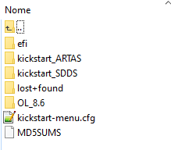

Figure – usbstick partition containing SDDS kickstart

The folder kickstart_SDDS contains the scripts to configure the KVM Host OS.

The OS version used for the Host will be Oracle Linux 8.6. The OS also contains the packages for the virtualisation software.

Inserting the usbstick in an USB port of the server and booting from the usbstick, the Host OS installation starts and displays the following menu, where it is possible to select the SDDS KVM or the ARTAS installation

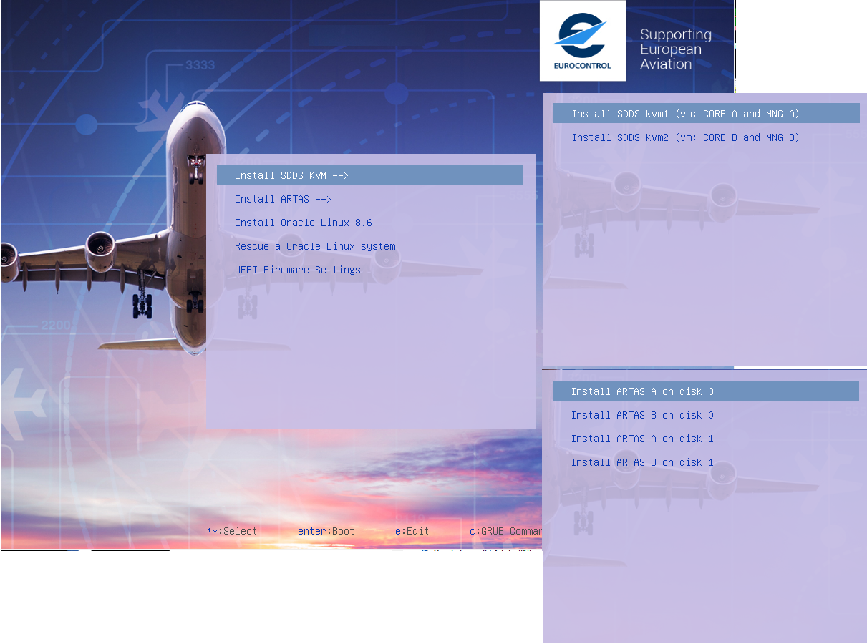

Figure – Boot menu

Selecting the SDDS KVM item, an additional menu is displayed where it is possible to select the installation of KVM Host 1 or KVM Host 2. Selecting KVM 1 or KVM 2 the OS installation starts.

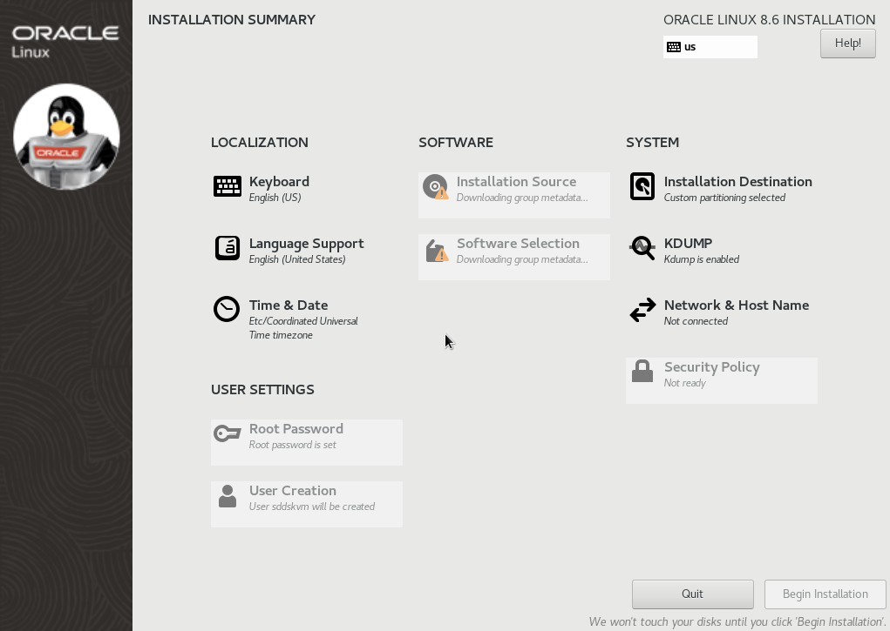

Figure – Installation summary

About ‘Users settings’ in Figure 34, the OS User will be sddskvm and it will be used to manage the virtual machines (Guests) CORE and MNG by the Virtual Manager graphical tool. Root user will be available, but the management of the Guest VMs will be performed by the non-privileged user sddskvm only (Linux KVM doesn’t require root privilege to manage VMs). About some configuration scripts (OS configuration, not KVM resources), that must be executed as root, described in the next pages, it has been used the same solution described in the ECP 736 also for the Host (scripts executed using sudo command)

During the OS installation, it is automatically applied a default configuration of the server and then created:

* two ILAN bridges (based on the network configuration defined in Figure 4) with the related mapping to the physical interfaces shown in Figure 36 and Figure 37,
* two IWAN bridges (based on the network configuration defined in Figure 4) with the related mapping to the physical interfaces shown in Figure 36 and Figure 37,
* two ELAN bridges (based on the network configuration defined in Figure 4) with the related mapping to the physical interfaces shown in Figure 36 and Figure 37,
* management network used to remotely connect (ssh, VNC) to the KVM Hosts.

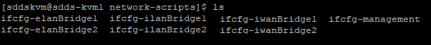

Figure – Network bridges and management interface

* NTP configuration (KVM1 and KVM2 NTP peers like the SDDS MNG)
* password for root and sddskvm user, enable VNC remote connection

The default mapping between the bridges and the physical network interfaces of the KVM Hosts is displayed in the following figures, distinguished for supported hardware.

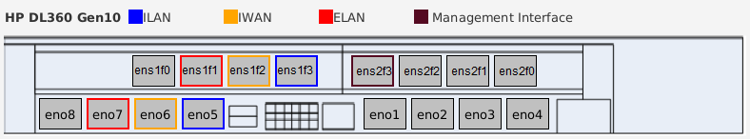

Figure – HP DL 360 Gen10: Bridges-interfaces network mapping and management interface

For HP DL 360 Gen10 mapping between bridges and physical interfaces, it has been chosen the same default LANs configuration used when CORE and MNG were installed on physical servers.

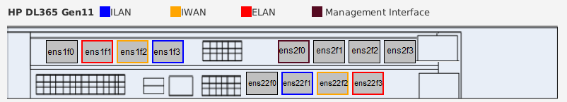

Figure – HP DL 365 Gen11: Bridges-interfaces network mapping and management interface

During the OS installation, it will be also created a tools folder containing useful tools, as described in the following figure:

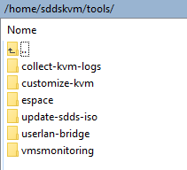

Figure – tools

* collect-kvm-log

The folder contains a script to collect the System logs

* customize-kvm

The folder contains a script to update the network settings about the bridges, the mapping between bridge and physical network interface, the management network, and the creation of the XLAN bridge. The script can be executed by sddskvm user using sudo.

* espace

The folder contains the ESPACE tool. This folder has been added for convenience, so that it’s possible to run Espace directly on the Host after Host OS installation, to prepare the iso to install the SDDS Guest. Running Espace in this way is NOT mandatory but can be useful. The use of Espace as before, not using this folder, is always possible and the choice is up to the user.

* update-sdds-iso

The folder contains the script used to update the default SDDS ISO file with the ESPACE tar. The result of the script will be a customised SDDS ISO file containing the ESPACE tar file to directly configure the CORE and MNG Guest OS.

* userlan-bridge

The folder contains the script to manage User Bridges. The script can be executed by sddskvm user using sudo.

* vmsmonitoring

The folder contains a properties file where it is possible to add the virtual machines to monitor. A script will be launched as service (interfacesmonitoring.service) on KVM Host boot, to monitor the physical network interfaces status and propagate their status to the virtual bridges, and then to the virtual network interfaces of the virtual machines mapped on them (2.2.2).

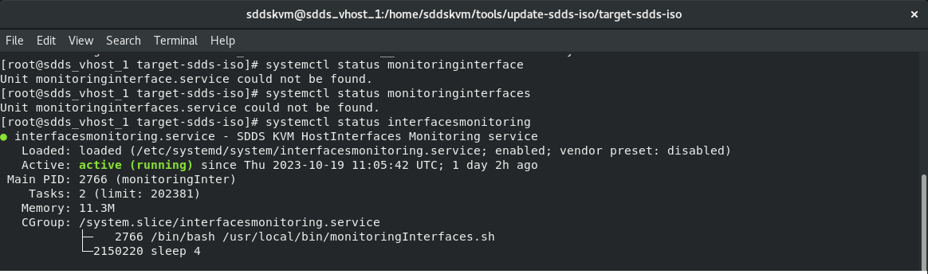

Figure – Service to monitori physical network interfaces status and propagate it to the network interfaces of the virtual machines defined on the KVM Host and configured to be monitored.

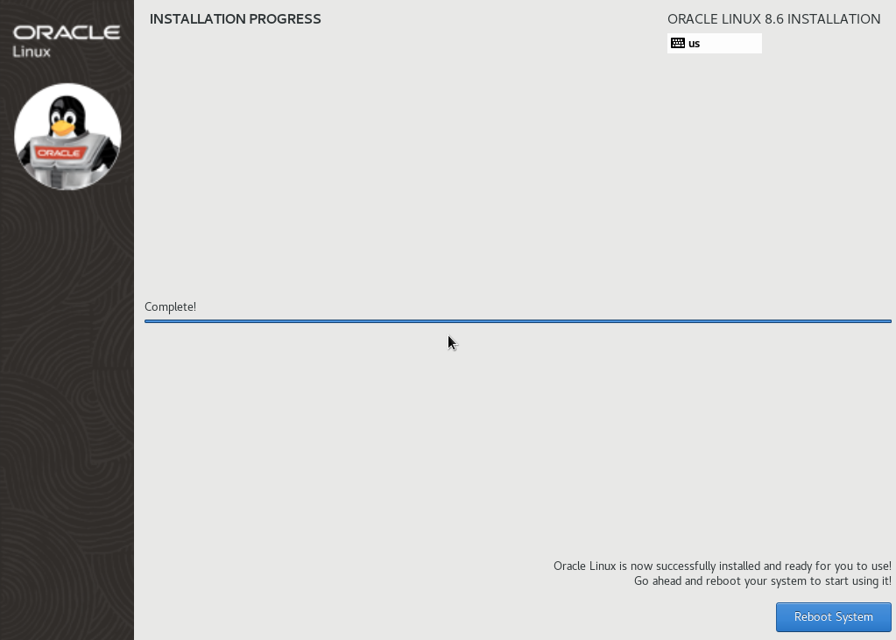

Figure – OS Installation terminated.

A customised configuration of the Host OS will be possible using the post-installation procedure or by ESPACE tool that has been extended in order to allow the OS customisation about SDDS Servers (MNG and CORE OS) and KVM Hosts.

The update of the tool is described in 2.2.3.

##### Host OS customisation by Post-installation

After the first KVM Host reboots (Figure 39), if an ESPACE tar has not been provided in the folder /kickstart_SDDS/ansp-extra/configuration of the usbstick, at the first root login a post-installation will start in order to customise the KVM Host settings.

The post-installation can be used to change or confirm the default settings. All the steps are described in the following.

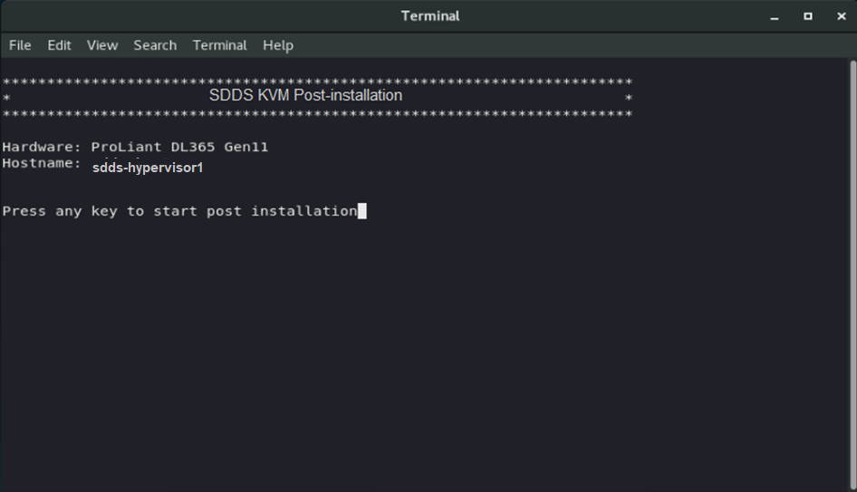

Figure – SDDS KVM Host Post-installation shell displayed on root’s login

In Figure 42, it is displayed the default configuration about the bridges. The bridges are like a virtual switch where a network interface of one or more virtual machines can be connected. A bridge is created providing a KVM Host physical network interface.

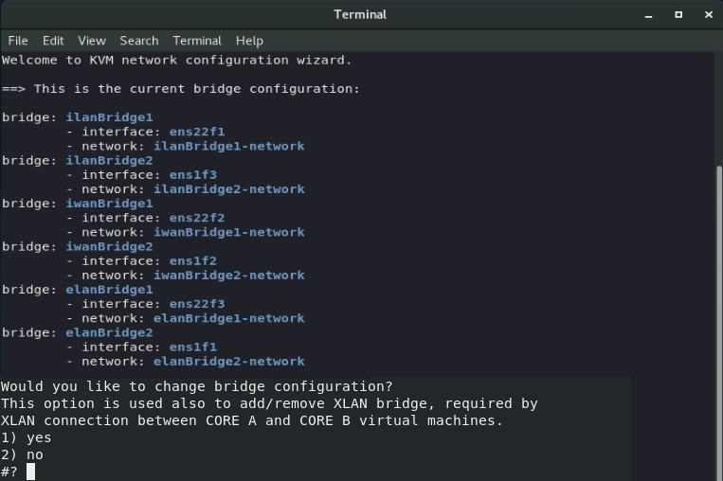

Figure – Step 1: Bridges and XLAN configuration menu

By the menu, selecting the option “yes” it is possible to customise the bridges for the System LANs (XLAN too). As default, during the OS installation, the following network bridges will be created: two for the ILAN, two for the IWAN and the two for the ELAN.

The XLAN bridge is not created by default, but in this step (step 1) it can be added if needed.

The User can customise the bridges, removing for example the iwanbridge2 and the elanbridge2 in case the CORE (and the MNG) does not use the bonding for the IWAN and the ELAN. Moreover, in case the XLAN is needed for the exchanging of Alive messages between the COREs, it is possible to create the XLAN bridge as displayed in Figure 43

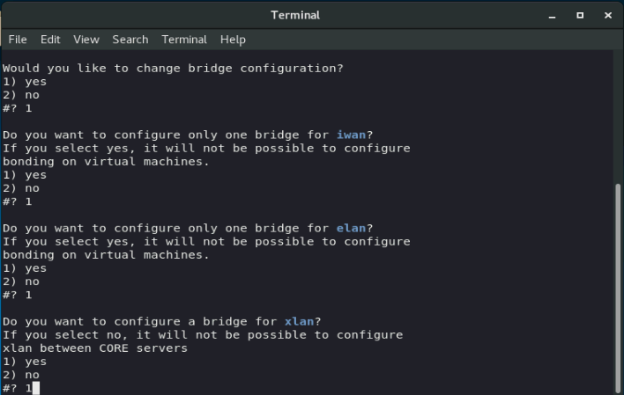

Figure – Step 1a: Required customisation example. (Remove bridges related to the ELAN and IWAN, creation of the xlanbridge)

In Figure 44 it is displayed the default mapping between the bridges and the KVM Host physical interfaces (example of Gen11 in the figure).

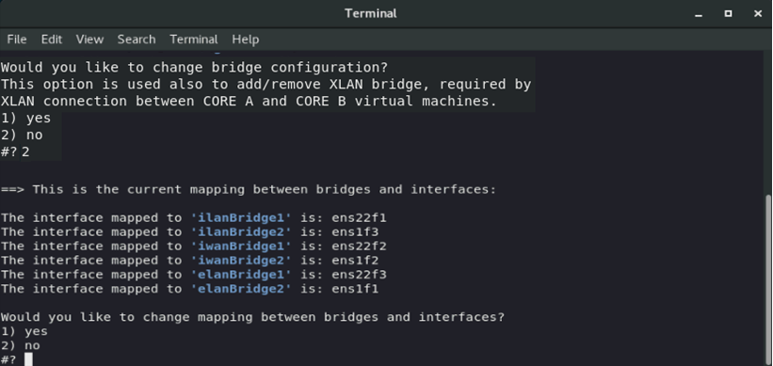

Figure – Step 2: Bridges-physical interfaces mapping

In the step 2 it is possible to change the physical network interfaces assigned to the bridges. If in the previous step it has been defined the XLAN bridge, then by this menu item it is possible to define the physical network interface to use for the XLAN bridge.

In Figure 45 it is displayed the default setting about the Management network.

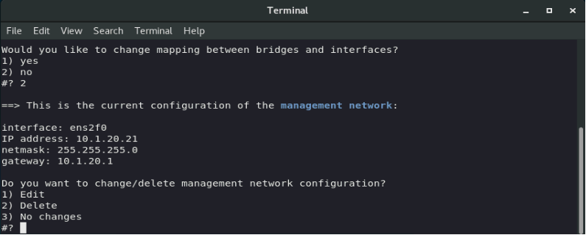

Figure – Step 3: Management network configuration

By default, the KVM Host OS installation also defines a Management network in order to connect remotely to the Host and also, for example, to synchronise the server with an NTP server. In the step 3 it is possible to change the default network settings for the management network and it is also possible to remove it (management network is optional).

In Figure 46 it is displayed the default configuration of the hosts file.

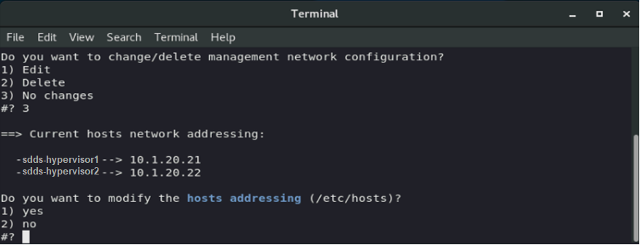

Figure – Step 4: hosts file configuration

By the step 4 it is possible to update the hosts file by changing the default IP addresses assigned to the KVM Host 1 and KVM Host 2 during the OS installation. The IP addresses are the ones of the Management network.

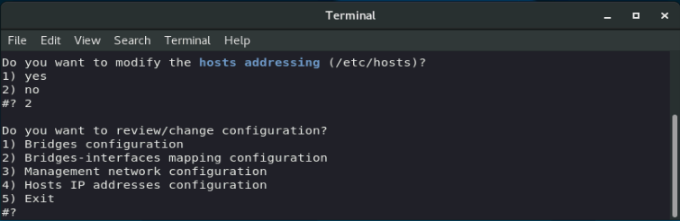

Figure – Main menu to review/change configuration.

In case it’s necessary, at a later time, to modify the bridges, the bridges-physical network interfaces mapping, the hosts file and the Management network, this can be performed using the script customizeKvm.sh, available in the folder /home/sddskvm/tools/customize-km. The script follows the same steps described in the previous figures.

At the end of the networks configuration, the post installation creates whatever is needed for the virtual machine environment, as displayed in Figure 48.

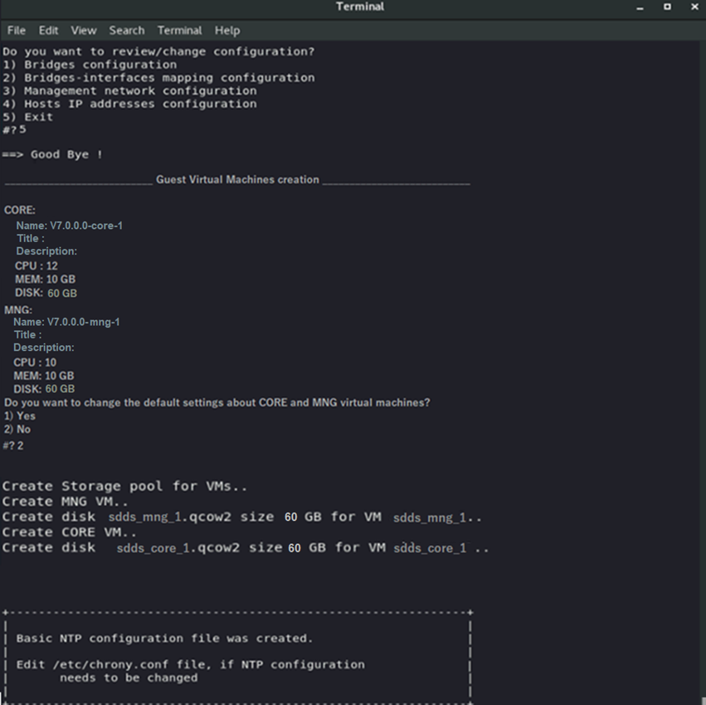

Figure 48 – Step 5: creation of the storage and virtual machines

In the step 5 it will be automatically created the storage pool, the disk files, the virtual networks and the CORE and MNG Guest virtual machines that must run on the KVM Host server. The User can confirm the default settings about the Guest name, the title, the description, the number of the CPUs, the memory and the disk size or he can customise them

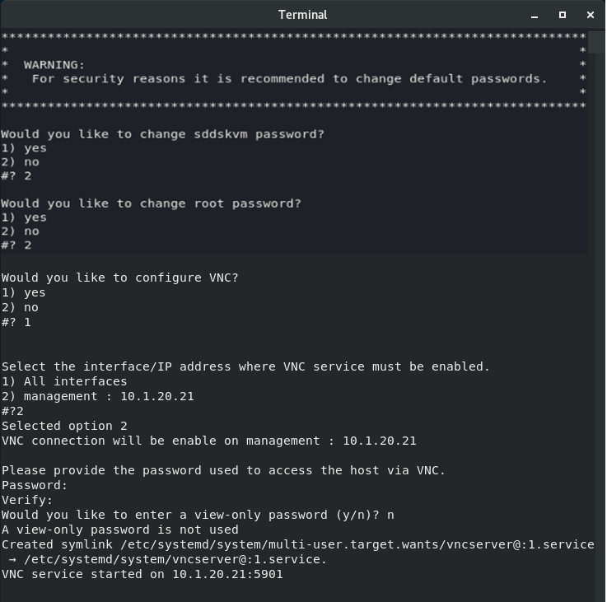

Figure – Final step: root and sddskvm passwords customisation and VNC settings (vnc password and interface to use)

In the last step it will be configured the root and sddskvm user passwords and enabled VNC if needed (VNC for sddskvm user only). It will be also possible to select a network interface/LAN where the VNC is listening.

At the end of the post-installation a reboot is required.

After the reboot and the login as sddskvm user, it is possible to run the ‘Virtual Machine Manager’ HMI and check the default settings of the two “empty” virtual machines created.

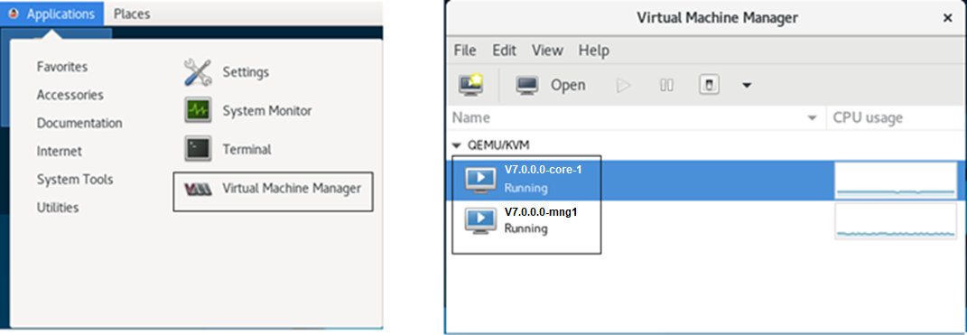

Figure –Virtual Machine Manager application with the two VMs automatically created during the post-installation (example for KVM1).

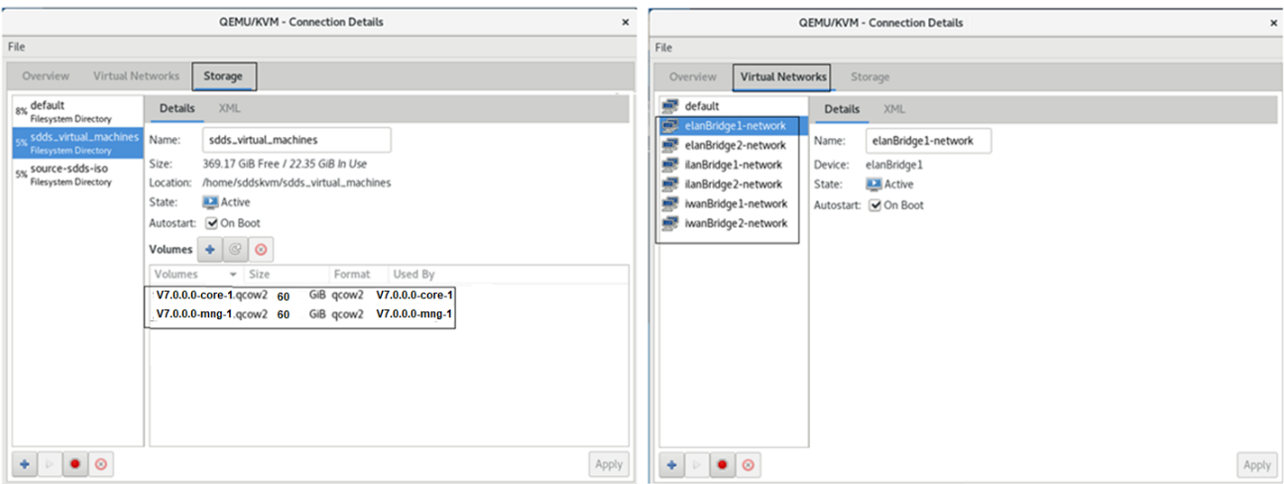

Figure – Virtual networks and storage created during the post-installation.

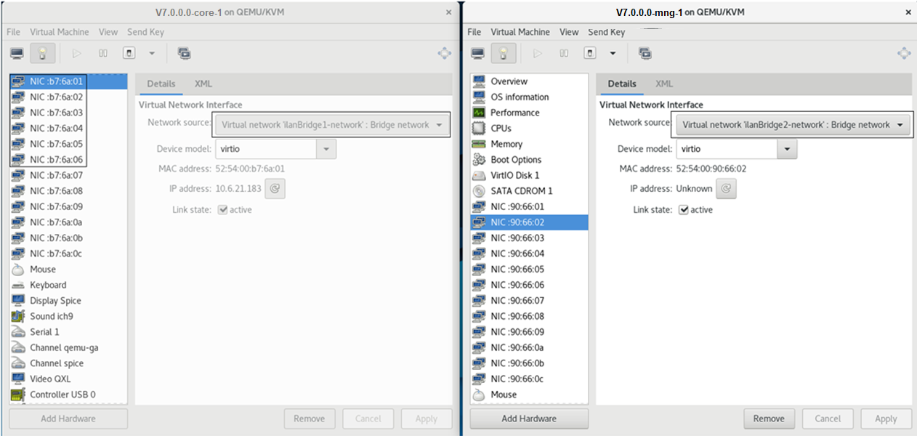

Figure – Virtual machines details.

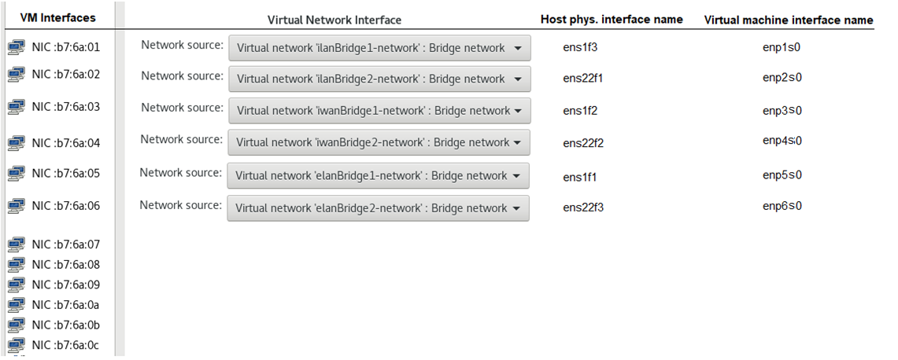

Figure – Default network interfaces mapping (DL 365 HP Gen11) automatically applied during post-installation.

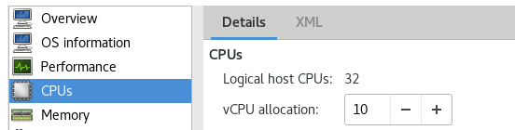

Figure – CORE and MNG VMs: CPU settings automatically applied during the post-installation.

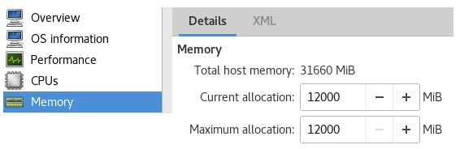

Figure – CORE and MNG VMs: Memory settings automatically applied during the post-installation.

The next step that must be manually executed by the User is to install the SDDS OS on the CORE and MNG virtual machines (Guests). In this phase, the User can also use ESPACE tool (/home/sddskvm/tools/espace) in order to create a tar file containing the OS customisation for the CORE and MNG virtual machines. It can be used the script /home/sddskvm/toold/update-sdds-iso/update_sdds_iso.sh to insert the ESPACE tar file in the SDDS OS default ISO file to create a customised ISO file already containing the ANSP settings for CORE and MNG virtual machines.

##### Host OS customisation by ESPACE tar file

When an ESPACE tar file is added to the usbstick folder /kickstart_SDDS/ansp-extra/configuration, then all the settings about the Host OS configuration (network bridges, mapping between bridges and physical network interfaces, management network, hosts file, NTP, password and VNC) are automatically applied and there’s no need for additional steps to configure the KVM Host server.

Although using ESPACE tar file, the step in Figure 48 (Create virtual machines) must be executed at the first root login. This step is needed to create the virtual machines environment and then to create the storage, the virtual networks and the virtual machines that cannot be created during the Host OS installation.

The step to create virtual machines environment, confirming the settings loaded using ESPACE configuration, is automatically executed pressing a key in the following shell opened at the first root login.

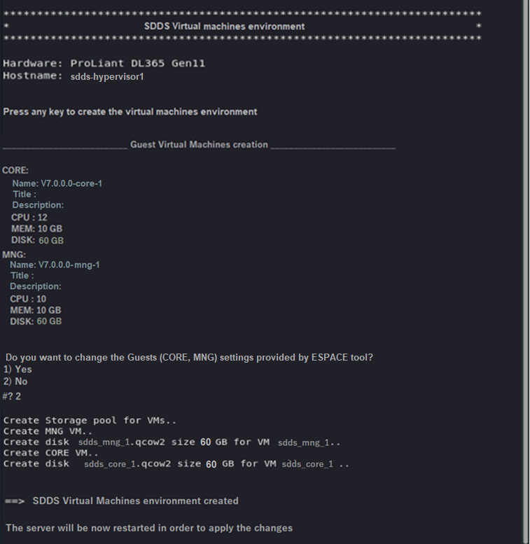

Figure 56 – Creation of Virtual machines environment.

The User can also change the settings about the Guest name, the title, the description, CPU, MEM and DISK size provided by ESPACE tar file.

At the end a reboot is required, and the procedure is terminated.

After the reboot and having logged in as sddskvm user, it is possible, as the previous procedure in 2.2.6.1.1, to run ‘Virtual Machine Manager’ HMI and check the settings of the two “empty” virtual machines created (Figure 50, Figure 51, Figure 52, Figure 53, Figure 54 and Figure 55).

The next step that must be manually executed by the User is to install the SDDS OS on the CORE and MNG virtual machines as described also to the end of 2.2.6.1.1.

### General aspects of the OS installation

The OS installation related to the Hosts and the Guests can be performed using a customised version of Oracle Linux 8.6. The Hosts OS (KVM Host OS) is available by an img.gz file that must be used to create a bootable USB stick. The Guests OS (SDDS Servers OS) is available as ISO file. When the OS is installed it will be performed a default configuration that can be customised during the post-installation phase (started at the first root login) or providing an ESPACE tar file. The Operating Systems of Host and Guest can be customised using ESPACE or the post-installation, independently. It means that it’s not required to use the same method for the customisation of the Host and the Guest (for example: use ESPACE to customise the Host and the post-installation to customise the Guest).

#### OS Installation using ESPACE

##### Hosts

A standard installation procedure will be the following:

1. Use ESPACE to create a tar with the configuration of the Hosts. The tar must be copied in the USB stick (/kickstart_SDDS/ansp-extra/configuration).
2. Insert in the USB stick, in the path /kickstart_SDDS/ansp-extra, additional user scripts that will be executed before the first Host OS reboot. These scripts, if needed, can be used for special settings about user customisation of some functionalities that are not related to the SDDS System.

The folder already contains the scripts:

* ansp-install.sh (the initial script where the user can insert the calls to his additional scripts)

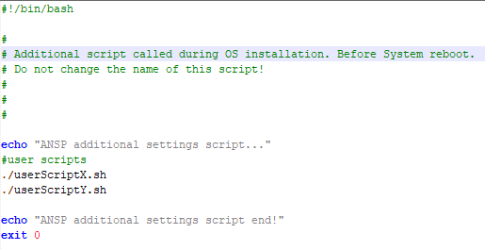

Figure 57 – Example of User scripts for Host customisation.

* ansp-packages.cfg

The file can be used to add OS packages to the Host OS default installation.

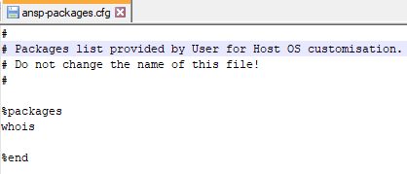

Figure 58 – Users additional packages for Host OS

1. Boot Host server by the USB stick and select the installation of the KVM Host 1 or Host 2
2. Reboot the server when the OS installation is complete.
3. Login as root to execute a minimal post-installation procedure in order to confirm the settings related to the Guests servers provided in the ESPACE tar. During this phase the Host resources (CPU, MEM and Disk size) will be displayed in order to be sure that the settings provided by ESPACE (offline tool) are really applicable on the Host.
4. Reboot the server and login as sddskvm user.
5. Start the Virtual Manager Application in order to display the created Guests (i.e.: V7.0.0.0-mng-1 and V7.0.0.0-core-1 on Host 1 and V7.0.0.0-mng-2, V7.0.0.0-core-2 on Host 2).

##### Guests

A standard installation procedure will be the following:

1. Use ESPACE to customise the SDDS OS configuration of the Guests (COREs, MNGs)An external instance of ESPACE, installed on any System, or an instance of ESPACE available on the Host by the link available on the desktop (automatically created during OS installation) can be used.. The ESPACE tar file, containing the SDDS Servers configuration, must be copied in the folder /home/sddskvm/tools/update-sdds-iso/espace-config-tar of the Host.
2. If the SDDS ISO (i.e: SDDS-OL8_6-V7.0.0.0-20231201.iso) is contained in the folder /kickstart_SDDS/sdds of the Host USB stick, it will be automatically copied in the folder /home/sddskvm/tools/update-sdds-iso/source-sdds-iso of the Host, otherwise it must be manually copied in the same path of the Host after the installation has been completed.

The ISO file contains only a default configuration of the Guests servers. The configuration can be customised using ESPACE tar file.

1. Insert, in the folder /home/sddskvm/tools/update-sdds-iso/additional-user-scripts of the Host, additional scripts provided by the Users. These scripts, if needed, can be used for special settings about user customisation of some functionalities that are not related to the SDDS System

The folder already contains the scripts:

* ansp-install.sh (the initial script where the user can insert the calls to his additional scripts )



Figure 59 – Users scripts.

* ansp-packages-core.cfg and ansp-packages-mng.cfg

The file can be used to add OS packages to the SDDS OS default installation

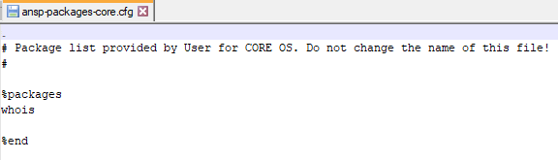

Figure 60 – Users additional packages

1. Copy, in the folder /home/sddskvm/tools/update-sdds-iso/sdds-version-tar of the Host, the SDDS Software Version (i.e. SDDS_INSTL_7.0.0.0-1.tar) if the User wants to install it during the OS customisation.

The SDDS Software Version can also be inserted directly in the Host USB stick (/kickstart_SDDS/sdds-extra/tools/update-sdds-iso/sdds-version-tar) and will be automatically copied in the path /home/sddskvm/tools/update-sdds-iso/sdds-version-tar during the Host OS installation.

1. Use the script /home/sddskvm/tools/update-sdds-iso/update_sdds_iso.sh in order to insert the ESPACE tar file (step 1 - /home/sddskvm/tools/update-sdds-iso/espace-config-tar), the user scripts (step 3 - /home/sddskvm/tools/update-sdds-iso/additional-user-scripts) and the SDDS Software Version (step 4 - /home/sddskvm/tools/update-sdds-iso/sdds-version-tar), in the target SDDS OS ISO. The final SDDS ISO, available in the path /home/sddskvm/tools/update-sdds-iso/target-sdds-iso, can be used to install and auto-configure the Guests servers. The same ISO file can be used for the Guests on Host 1 (MNG 1 and CORE 1) and Host 2 (MNG 2 and CORE 2).
2. Use the Virtual Manager graphical application to install the customised SDDS OS (/home/sddskvm/tools/update-sdds-iso/target-sdds-iso) on the Guests.

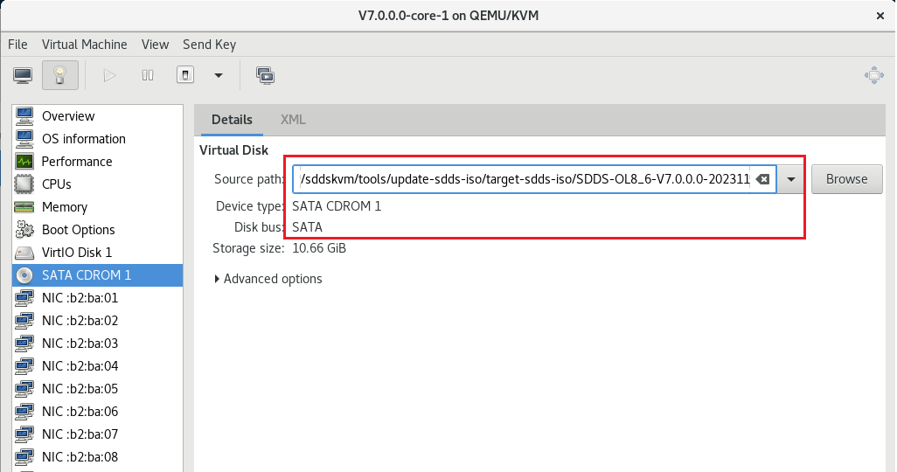

Figure 61 – Load and install SDDS OS ISO.

1. At the end of the SDDS OS installation on the Guest a reboot of the Guest is required.

If the User has not added the SDDS Software to the ISO file, then the OS installation will be terminated, otherwise, at the first root login, the SDDS Software installation will be started automatically.

#### OS Installation using post-installation

The post-installation is a phase used to customise the OS by an interaction with the User.

##### Hosts

A standard installation procedure will be the following:

1. Insert in the USB stick, in the path /kickstart_SDDS/ansp-extra, additional user scripts that will be executed before the first Host OS reboot. These scripts, if needed, can be used for special settings about user customisation of some functionalities that are not related to the SDDS System. (The same of step 2 in 2.2.7.1.1 ). This folder can also contain OS extra rpms and the scripts for their installation.
2. Boot Host server by the USB stick and select the installation of the KVM Host 1 or Host 2
3. Reboot the server when the OS installation is complete.
4. Login as root to execute a full post-installation procedure in order to customise all settings about the network bridges, management network, hosts file, users password, VNC and Guests servers (CPUs number, MEM size, Disk size).
5. Reboot the server and login as sddskvm user.

Start the Linux KVM Virtual Manager Application in order to display the created Guests (i.e.: V7.0.0.0-mng-1 and V7.0.0.0-core-1 on Host 1 and V7.0.0.0-mng-2, V7.0.0.0-core-2 on Host 2).

##### Guests

A standard installation procedure will be the following:

1. Copy, in the path /home/sddskvm/tools/update-sdds-iso/source-sdds-iso of the Host, the SDDS ISO file (i.e: SDDS-OL8_6-V7.0.0.0-20231201.iso).

The ISO file contains only a default configuration of the Guests servers. The configuration can be customised using the post-installation phase.

1. Insert, in the folder /home/sddskvm/tools/update-sdds-iso/additional-user-scripts of the Host, additional scripts provided by the Users. These scripts. If needed, can be used for special settings about user customisation of some functionalities that are not related to the SDDS System. (The same of step 3 in 2.2.7.1.2). This folder can also contain OS extra rpms and the scripts for their installation.
2. Copy, in the folder /home/sddskvm/tools/update-sdds-iso/sdds-version-tar of the Host, the SDDS Software Version (i.e. SDDS_INSTL_7.0.0.0-1.tar) if the User wants to install it during the OS installation and customisation.

The SDDS Software Version can also be inserted directly in the Host USB stick (/kickstart_SDDS/sdds-extra/tools/update-sdds-iso/sdds-version-tar) and will be automatically copied in the path /home/sddskvm/tools/update-sdds-iso/sdds-version-tar during the Host OS installation.

1. Use the script /home/sddskvm/tools/update-sdds-iso/update_sdds_iso.sh in order to insert the user scripts (step 2 - /home/sddskvm/tools/update-sdds-iso/additional-user-scripts) and the SDDS Software Version (step 3 - /home/sddskvm/tools/update-sdds-iso/sdds-version-tar), in the target SDDS OS ISO. The final SDDS ISO, available in the path /home/sddskvm/tools/update-sdds-iso/target-sdds-iso, can be used to install and to apply a first user customisation of the Guests servers. The same ISO file can be used for the Guests on Host 1 (MNG 1 and CORE 1) and Host 2 (MNG 2 and CORE 2).
2. Use the Virtual Manager graphical application to install the customised SDDS OS on the Guests. (the same of step 6 in 2.2.7.1.2)

At the end of the SDDS OS installation a reboot is required. At the first root login, the post-installation will be started in order to apply a full customisation of the SDDS Servers (hosts file, network, bonding, XLAN, users password, VNC, etc.). If the SDDS Software tar has been added to the ISO file than, at the end of the post installation, the SDDS Software installation will be automatically started.

The SDDS Guests and KVM Hosts OS installation and customisation can also be performed using the default content of the USB stick and the SDDS ISO file, without creating a new ISO file but simply using the post-installation for both Operating Systems (Hosts and Guests). All the needed settings for the SDDS System can be applied also in this way.

### Considerations about NTP, VNC, LDAP, SNMP, RSYSLOG

The introduction of the KVM Host and the new network architecture affects the NTP, VNC, LDAP (ECP769), SNMP (ECP699, ECP771, ECP821) and RSYSLOG (ECP649).

The SDDS will include a dedicated manual for the KVM solution, where it will be explained how to configure additional network interfaces for a more flexible use of the above-mentioned services.

For NTP, it’s recommended to apply the following configuration:

* Host: manual configuration of a network interface for NTP, or use of the Management network interface.
* Guest: default configuration with CORE synchronised to MNG, MNG synchronised to NTP by IP address of NTP server.

For VNC, it’s recommended to apply the following configuration:

* Host: manual configuration of a “Graphical LAN” for VNC access to the Host, or use of the Management Network interface for VNC access to the Host. The VNC access can be bound to the dedicated user sddskvm (ECP837). An additional VNC service can be configured for an access based on username and password (LDAP related – ECP769).
* MNG Guest: manual configuration of a “Graphical LAN” for VNC access to the MNG Guest. The VNC access can be bound to the dedicated user sdds (ECP837). An additional VNC service can be configured for an access based on username and password (LDAP related – ECP769).

For LDAP, it’s recommended to apply the following configuration:

* Host: Network Management interface.
* MNG Guest: ILAN, ELAN, IWAN or a manually created interface.
* CORE Guest: no need. CORE Guest can be accessed from the MNG or from the KVM console.

For SNMP, it’s recommended to apply the following configuration:

* MNG Guest: recommended ELAN and/or IWAN creation for SNMP access.
* Host: Network Management interface.

For RSYSLOG, it’s recommended to apply the following configuration:

* MNG: ILAN or a manually created interface.
* CORE: ILAN, ELAN, IWAN or a User LAN. Another possibility is to forward the logs to the MNG by ILAN and, in turn, forwarding the logs from the MNG (manual configuration).

# Detailed Functionality

*<Indication to SCN update:*

*For each subchapters verify whether the System Change impacts the corresponding document released by EC.*

If a change is needed, choose a reporting method (Word track Changes or SCN Before & After) and apply your changes according to SCN Guidelines.

Please leave unmodified sections marked as empty ("No changes").>

## SSS changes

No changes.

## SRS changes

### SRS-CORE_DIST changes

No changes.

### SRS-CORE_MNG changes

No changes.

### SRS-CORE_REC changes

No changes.

### SRS-MNG_CONF changes

No changes.

### SRS-MNG_SMC changes

No changes.

### SRS-ESPACE changes

No changes.

## Design document changes

### SSDD changes

No changes.

### CORE_DIST-SDD changes

No changes.

### CORE_MNG-SDD changes

No changes.

### CORE_REC-SDD changes

No changes.

### MNG_CONF-SDD changes

No changes.

### MNG_SMC-SDD changes

No changes.

### ESPACE-SDD changes

No changes.

## User documentation

### MAN

No changes.

### CONF

No changes.

### MAN ESPACE

No changes.

### GLO

No changes.

### SIM

No changes.

### SUM

No changes.

### VDD

No changes.

### HS

No changes.

### ICD

No changes.

### OIM

No changes.

### RCM

No changes.

### SCM

No changes.

### RN

No changes.

## Safety Analysis

ToDo

### Failure mode

#### Preliminary Functional Hazard Analysis

ToDo

##### Safety Objectives List

ToDo

### Fault Tree Analysis (FTA)

ToDo

### FMECA

ToDo

### FTA and FMECA Results

ToDo

### Additional Safety relevant Requirements

ToDo

# Test Strategy

## TEST Set n

<Specify which requirement(s) will be covered by the test set n. Only in exceptionally rare cases, if a requirement is only partially tested please list reasons why it is not completely tested.

Use the following table in case of SSS>

| **Version** | **SSS Requirement ID** | **Linked SRS ID** | **Test ID** |
| --- | --- | --- | --- |
|  |  |  |  |
|  |  |  |  |

<Otherwise, use the following table in case of SRS:>

| **Version** | **SRS Requirement ID** | **Test ID** |
| --- | --- | --- |
|  |  |  |
|  |  |  |

### High level description of functional tests

<For the described tests, specify

* which function / feature is tested (objective of the test)
* what qualification method manual/automatic (test, demonstration, analysis etc.) is envisaged
* characteristics of any specialised test data (e.g. scenario, database, parameters)>

### Test tools

<If any of the tests require special test tools which are not commonly shared between EUROCONTROL and the Industrial Partner, please name these tools, describe their role and justify why they have to be used (i.e. in which way do the standard tools not meet the need).>

### Test environment

<Describe the required test environment to conduct the functional/non-functional and regression tests. Think about hardware/software platforms, configuration and any other special setup or external interface needs (e.g. networks, timing etc.).>

Tests were executed in the following environment:

| **Version** | **Hardware** | **OS Version** |
| --- | --- | --- |
|  |  |  |

## Regression Analysis

<Identify the regressions that might be introduced by the changes described in this SCN, and which additional tests, if any, are intended to demonstrate non-regression.

Such additional tests could be existing tests or may need to be created. They may also be used to mitigate partially tested requirements.

All new, existing and/or modified Regression Test Description IDs shall be listed in the table below. >

All changes will be tested and verified for possible regressions with the tests listed below:

| **Version** | **SSS/SRS Requirement ID** | **Test ID** |
| --- | --- | --- |
| *…* | *…* | *…* |
| *…* | *…* | *…* |

<Otherwise:>

All changes are already tested and verified with the above mentioned test, which itself could serve as a regression test in future.

# Additional Comments

<The Additional Comments section should be used for placing supplementary information related to the current ETR or ECP.

Otherwise:>

No Additional Comments.

1. Reference: www.first.org/tlp